






Present and display food products
D1.HCC.CL2.19
Trainer Guide

Present and display food products

D1.HCC.CL2.19

Trainer Guide




Project Base
William Angliss Institute of TAFE
555 La Trobe Street
Melbourne 3000 Victoria
Telephone: | (03) 9606 2111
Facsimile: | (03) 9670 1330
Acknowledgements
Project Director: | Wayne Crosbie
Chief Writer: | Alan Hickman
Subject Writer: | Brad Harris
Project Manager/Editor: | Alan Maguire
DTP/Production: | Daniel Chee, Mai Vu, Kaly Quach

The Association of Southeast Asian Nations (ASEAN) was established on 8 August 1967. The Member States of the Association are Brunei Darussalam, Cambodia, Indonesia, Lao PDR, Malaysia, Myanmar, Philippines, Singapore, Thailand and Viet Nam.
The ASEAN Secretariat is based in Jakarta, Indonesia.
General Information on ASEAN appears online at the ASEAN Website: www.asean.org.
All text is produced by William Angliss Institute of TAFE for the ASEAN Project on “Toolbox Development for Front Office, Food and Beverage Services and Food Production Divisions”.
This publication is supported by Australian Aid through the ASEAN-Australia Development Cooperation Program Phase II (AADCP II).
Copyright: Association of Southeast Asian Nations (ASEAN) 2013.
All rights reserved.
Disclaimer
Every effort has been made to ensure that this publication is free from errors or omissions. However, you should conduct your own enquiries and seek professional advice before relying on any fact, statement or matter contained in this book. ASEAN Secretariat and William Angliss Institute of TAFE are not responsible for any injury, loss or damage as a result of material included or omitted from this course. Information in this module is current at the time of publication. Time of publication is indicated in the date stamp at the bottom of each page.
Some images appearing in this resource have been purchased from various stock photography suppliers and other third party copyright owners and as such are non-transferable and non-exclusive.
Additional images have been sourced from Flickr and are used under:
http://creativecommons.org/licenses/by/2.0/deed.en
http://www.sxc.hu/
File name: TG_Present_&_display_food_products _FN_240114





Table of contents
Competency Based Training (CBT) and assessment – An introduction for trainers 1
Competency standard 11
Notes and PowerPoint slides 19
Recommended training equipment 75
Instructions for Trainers for using PowerPoint – Presenter View 77
Appendix – ASEAN acronyms 79

Competency Based Training (CBT) and assessment – An introduction for trainers

Competency
Competency refers to the ability to perform particular tasks and duties to the standard of performance expected in the workplace.
Competency requires the application of specified knowledge, skills and attitudes relevant to effective participation, consistently over time and in the workplace environment.
The essential skills and knowledge are either identified separately or combined.
Knowledge identifies what a person needs to know to perform the work in an informed and effective manner.
Skills describe the application of knowledge to situations where understanding is converted into a workplace outcome.
Attitude describes the founding reasons behind the need for certain knowledge or why skills are performed in a specified manner.
Competency covers all aspects of workplace performance and involves:
- Performing individual tasks
- Managing a range of different tasks
- Responding to contingencies or breakdowns
- Dealing with the responsibilities of the workplace
- Working with others.

Unit of Competency
Like with any training qualification or program, a range of subject topics are identified that focus on the ability in a certain work area, responsibility or function.
Each manual focuses on a specific unit of competency that applies in the hospitality workplace.
In this manual a unit of competency is identified as a ‘unit’.
Each unit of competency identifies a discrete workplace requirement and includes:
- Knowledge and skills that underpin competency
- Language, literacy and numeracy
- Occupational health and safety requirements.
Each unit of competency must be adhered to in training and assessment to ensure consistency of outcomes.

Element of Competency
An element of competency describes the essential outcomes within a unit of competency.
The elements of competency are the basic building blocks of the unit of competency. They describe in terms of outcomes the significant functions and tasks that make up the competency.
In this manual elements of competency are identified as an ‘element’.

Performance criteria
Performance criteria indicate the standard of performance that is required to demonstrate achievement within an element of competency. The standards reflect identified industry skill needs.
Performance criteria will be made up of certain specified skills, knowledge and attitudes.

Learning
For the purpose of this manual learning incorporates two key activities:
- Training
- Assessment.
Both of these activities will be discussed in detail in this introduction.
Today training and assessment can be delivered in a variety of ways. It may be provided to participants:
- On-the-job – in the workplace
- Off-the-job – at an educational institution or dedicated training environment
- As a combination of these two options.
No longer is it necessary for learners to be absent from the workplace for long periods of time in order to obtain recognised and accredited qualifications.

Learning Approaches
This manual will identify two avenues to facilitate learning:
Competency Based Training (CBT)
This is the strategy of developing a participant’s competency.
Educational institutions utilise a range of training strategies to ensure that participants are able to gain the knowledge and skills required for successful:
- Completion of the training program or qualification
- Implementation in the workplace.
The strategies selected should be chosen based on suitability and the learning styles of participants.

Competency Based Assessment (CBA)
This is the strategy of assessing competency of a participant.
Educational institutions utilise a range of assessment strategies to ensure that participants are assessed in a manner that demonstrates validity, fairness, reliability, flexibility and fairness of assessment processes.

Flexibility in Learning
It is important to note that flexibility in training and assessment strategies is required to meet the needs of participants who may have learning difficulties. The strategies used will vary, taking into account the needs of individual participants with learning difficulties. However they will be applied in a manner which does not discriminate against the participant or the participant body as a whole.
Catering for Participant Diversity
Participants have diverse backgrounds, needs and interests. When planning training and assessment activities to cater for individual differences, trainers and assessors should:
- Consider individuals’ experiences, learning styles and interests
- Develop questions and activities that are aimed at different levels of ability
- Modify the expectations for some participants
- Provide opportunities for a variety of forms of participation, such as individual, pair and small group activities
- Assess participants based on individual progress and outcomes.
The diversity among participants also provides a good reason for building up a learning community in which participants support each other’s learning.
Participant Centred Learning
This involves taking into account structuring training and assessment that:
- Builds on strengths – Training environments need to demonstrate the many positive features of local participants (such as the attribution of academic success to effort, and the social nature of achievement motivation) and of their trainers (such as a strong emphasis on subject disciplines and moral responsibility). These strengths and uniqueness of local participants and trainers should be acknowledged and treasured
- Acknowledges prior knowledge and experience – The learning activities should be planned with participants’ prior knowledge and experience in mind
- Understands learning objectives – Each learning activity should have clear learning objectives and participants should be informed of them at the outset. Trainers should also be clear about the purpose of assignments and explain their significance to participants
- Teaches for understanding – The pedagogies chosen should aim at enabling participants to act and think flexibly with what they know
- Teaches for independent learning – Generic skills and reflection should be nurtured through learning activities in appropriate contexts of the curriculum. Participants should be encouraged to take responsibility for their own learning
- Enhances motivation – Learning is most effective when participants are motivated. Various strategies should be used to arouse the interest of participants
- Makes effective use of resources – A variety of teaching resources can be employed as tools for learning
- Maximises engagement – In conducting learning activities, it is important for the minds of participants to be actively engaged
- Aligns assessment with learning and teaching – Feedback and assessment should be an integral part of learning and teaching
- Caters for learner diversity – Trainers should be aware that participants have different characteristics and strengths and try to nurture these rather than impose a standard set of expectations.
Active Learning
The goal of nurturing independent learning in participants does not imply that they always have to work in isolation or solely in a classroom. On the contrary, the construction of knowledge in tourism and hospitality studies can often best be carried out in collaboration with others in the field. Sharing experiences, insights and views on issues of common concern, and working together to collect information through conducting investigative studies in the field (active learning) can contribute a lot to their eventual success.
Active learning has an important part to play in fostering a sense of community in the class. First, to operate successfully, a learning community requires an ethos of acceptance and a sense of trust among participants, and between them and their trainers. Trainers can help to foster acceptance and trust through encouragement and personal example, and by allowing participants to take risks as they explore and articulate their views, however immature these may appear to be. Participants also come to realise that their classmates (and their trainers) are partners in learning and solving.
Trainers can also encourage cooperative learning by designing appropriate group learning tasks, which include, for example, collecting background information, conducting small-scale surveys, or producing media presentations on certain issues and themes. Participants need to be reminded that, while they should work towards successful completion of the field tasks, developing positive peer relationships in the process is an important objective of all group work.

Competency Based Training (CBT)
Principle of Competency Based Training
Competency based training is aimed at developing the knowledge, skills and attitudes of participants, through a variety of training tools.
Training Strategies
The aims of this curriculum are to enable participants to:
- Undertake a variety of subject courses that are relevant to industry in the current environment
- Learn current industry skills, information and trends relevant to industry
- Learn through a range of practical and theoretical approaches
- Be able to identify, explore and solve issues in a productive manner
- Be able to become confident, equipped and flexible managers of the future
- Be ‘job ready’ and a valuable employee in the industry upon graduation of any qualification level.
To ensure participants are able to gain the knowledge and skills required to meet competency in each unit of competency in the qualification, a range of training delivery modes are used.
Types of Training
In choosing learning and teaching strategies, trainers should take into account the practical, complex and multi-disciplinary nature of the subject area, as well as their participant’s prior knowledge, learning styles and abilities.
Training outcomes can be attained by utilising one or more delivery methods:
Lecture/Tutorial
This is a common method of training involving transfer of information from the trainer to the participants. It is an effective approach to introduce new concepts or information to the learners and also to build upon the existing knowledge. The listener is expected to reflect on the subject and seek clarifications on the doubts.
Demonstration
Demonstration is a very effective training method that involves a trainer showing a participant how to perform a task or activity. Through a visual demonstration, trainers may also explain reasoning behind certain actions or provide supplementary information to help facilitate understanding.
Group Discussions
Brainstorming in which all the members in a group express their ideas, views and opinions on a given topic. It is a free flow and exchange of knowledge among the participants and the trainer. The discussion is carried out by the group on the basis of their own experience, perceptions and values. This will facilitate acquiring new knowledge. When everybody is expected to participate in the group discussion, even the introverted persons will also get stimulated and try to articulate their feelings.
The ideas that emerge in the discussions should be noted down and presentations are to be made by the groups. Sometimes consensus needs to be arrived at on a given topic. Group discussions are to be held under the moderation of a leader guided by the trainer. Group discussion technique triggers thinking process, encourages interactions and enhances communication skills.
Role Play
This is a common and very effective method of bringing into the classroom real life situations, which may not otherwise be possible. Participants are made to enact a particular role so as to give a real feel of the roles they may be called upon to play. This enables participants to understand the behaviour of others as well as their own emotions and feelings. The instructor must brief the role players on what is expected of them. The role player may either be given a ready-made script, which they can memorize and enact, or they may be required to develop their own scripts around a given situation. This technique is extremely useful in understanding creative selling techniques and human relations. It can be entertaining and energizing and it helps the reserved and less literate to express their feelings.

Simulation Games
When trainees need to become aware of something that they have not been conscious of, simulations can be a useful mechanism. Simulation games are a method based on "here and now" experience shared by all the participants. The games focus on the participation of the trainees and their willingness to share their ideas with others. A "near real life" situation is created providing an opportunity to which they apply themselves by adopting certain behaviour. They then experience the impact of their behaviour on the situation. It is carried out to generate responses and reactions based on the real feelings of the participants, which are subsequently analysed by the trainer.
While use of simulation games can result in very effective learning, it needs considerable trainer competence to analyse the situations.
Individual /Group Exercises
Exercises are often introduced to find out how much the participant has assimilated. This method involves imparting instructions to participants on a particular subject through use of written exercises. In the group exercises, the entire class is divided into small groups, and members are asked to collaborate to arrive at a consensus or solution to a problem.
Case Study
This is a training method that enables the trainer and the participant to experience a real life situation. It may be on account of events in the past or situations in the present, in which there may be one or more problems to be solved and decisions to be taken. The basic objective of a case study is to help participants diagnose, analyse and/or solve a particular problem and to make them internalize the critical inputs delivered in the training. Questions are generally given at the end of the case study to direct the participants and to stimulate their thinking towards possible solutions. Studies may be presented in written or verbal form.
Field Visit
This involves a carefully planned visit or tour to a place of learning or interest. The idea is to give first-hand knowledge by personal observation of field situations, and to relate theory with practice. The emphasis is on observing, exploring, asking questions and understanding. The trainer should remember to brief the participants about what they should observe and about the customs and norms that need to be respected.
Group Presentation
The participants are asked to work in groups and produce the results and findings of their group work to the members of another sub-group. By this method participants get a good picture of each other's views and perceptions on the topic and they are able to compare them with their own point of view. The pooling and sharing of findings enriches the discussion and learning process.
Practice Sessions
This method is of paramount importance for skills training. Participants are provided with an opportunity to practice in a controlled situation what they have learnt. It could be real life or through a make-believe situation.

Games
This is a group process and includes those methods that involve usually fun-based activity, aimed at conveying feelings and experiences, which are everyday in nature, and applying them within the game being played. A game has set rules and regulations, and may or may not include a competitive element. After the game is played, it is essential that the participants be debriefed and their lessons and experiences consolidated by the trainer.
Research
Trainers may require learners to undertake research activities, including online research, to gather information or further understanding about a specific subject area.

Competency Based Assessment (CBA)
Principle of Competency Based Assessment
Competency based assessment is aimed at compiling a list of evidence that shows that a person is competent in a particular unit of competency.
Competencies are gained through a multitude of ways including:
- Training and development programs
- Formal education
- Life experience
- Apprenticeships
- On-the-job experience
- Self-help programs.
All of these together contribute to job competence in a person. Ultimately, assessors and participants work together, through the ‘collection of evidence’ in determining overall competence.
This evidence can be collected:
- Using different formats
- Using different people
- Collected over a period of time.
The assessor who is ideally someone with considerable experience in the area being assessed, reviews the evidence and verifies the person as being competent or not.
Flexibility in Assessment
Whilst allocated assessment tools have been identified for this subject, all attempts are made to determine competency and suitable alternate assessment tools may be used, according to the requirements of the participant.
The assessment needs to be equitable for all participants, taking into account their cultural and linguistic needs.
Competency must be proven regardless of:
- Language
- Delivery Method
- Assessment Method.
Assessment Objectives
The assessment tools used for subjects are designed to determine competency against the ‘elements of competency’ and their associated ‘performance criteria’.
The assessment tools are used to identify sufficient:
- Knowledge, including underpinning knowledge
- Skills
- Attitudes
Assessment tools are activities that trainees are required to undertake to prove participant competency in this subject.
All assessments must be completed satisfactorily for participants to obtain competence in this subject. There are no exceptions to this requirement, however, it is possible that in some cases several assessment items may be combined and assessed together.
Types of Assessment
Allocated Assessment Tools
There are a number of assessment tools that are used to determine competency in this subject:
- Work projects
- Written questions
- Oral questions
- Third Party Report
- Observation Checklist.
Instructions on how assessors should conduct these assessment methods are explained in the Assessment Manuals.
Alternative Assessment Tools
Whilst this subject has identified assessment tools, as indicated above, this does not restrict the assessor from using different assessment methods to measure the competency of a participant.
Evidence is simply proof that the assessor gathers to show participants can actually do what they are required to do.
Whilst there is a distinct requirement for participants to demonstrate competency, there are many and diverse sources of evidence available to the assessor.
Ongoing performance at work, as verified by a supervisor or physical evidence, can count towards assessment. Additionally, the assessor can talk to customers or work colleagues to gather evidence about performance.
A range of assessment methods to assess competency include:
- Practical demonstrations
- Practical demonstrations in simulated work conditions
- Problem solving
- Portfolios of evidence
- Critical incident reports
- Journals
- Oral presentations
- Interviews
- Videos
- Visuals: slides, audio tapes
- Case studies
- Log books
- Projects
- Role plays
- Group projects
- Group discussions
- Examinations.
Recognition of Prior Learning
Recognition of Prior Learning is the process that gives current industry professionals who do not have a formal qualification, the opportunity to benchmark their extensive skills and experience against the standards set out in each unit of competency/subject.
Also known as a Skills Recognition Audit (SRA), this process is a learning and assessment pathway which encompasses:
- Recognition of Current Competencies (RCC)
- Skills auditing
- Gap analysis and training
- Credit transfer.
Assessing competency
As mentioned, assessment is the process of identifying a participant’s current knowledge, skills and attitudes sets against all elements of competency within a unit of competency. Traditionally in education, grades or marks were given to participants, dependent on how many questions the participant successfully answered in an assessment tool.
Competency based assessment does not award grades, but simply identifies if the participant has the knowledge, skills and attitudes to undertake the required task to the specified standard.
Therefore, when assessing competency, an assessor has two possible results that can be awarded:
- Pass Competent (PC)
- Not Yet Competent (NYC).
Pass Competent (PC)
If the participant is able to successfully answer or demonstrate what is required, to the expected standards of the performance criteria, they will be deemed as ‘Pass Competent’ (PC).
The assessor will award a ‘Pass Competent’ (PC) if they feel the participant has the necessary knowledge, skills and attitudes in all assessment tasks for a unit.
Not Yet Competent’ (NYC)
If the participant is unable to answer or demonstrate competency to the desired standard, they will be deemed to be ‘Not Yet Competent’ (NYC).
This does not mean the participant will need to complete all the assessment tasks again. The focus will be on the specific assessment tasks that were not performed to the expected standards.
The participant may be required to:
a) Undertake further training or instruction
b) Undertake the assessment task again until they are deemed to be ‘Pass Competent’.

Competency standard
UNIT TITLE: PRESENT AND DISPLAY FOOD PRODUCTS |  |  |  | NOMINAL HOURS: 30
UNIT NUMBER: D1.HCC.CL2.19
UNIT DESCRIPTOR: This unit deals with skills and knowledge required by cooks and chefs to present and display a range of food products in commercial food operations
ELEMENTS AND PERFORMANCE CRITERIA | UNIT VARIABLE AND ASSESSMENT GUIDE
Element 1: Prepare garnishes and accompaniments  - Identify menu items that require garnishes and/or accompaniments  - Prepare various garnish and/or accompaniments  - Set up for service  Element 2: Plate and present foods  - Portion food items to enterprise standards  - Provide sufficient and appropriate service equipment and service platforms  - Plate and display food items to menu style  - Present food neatly and attractively  Element 3: Store garnishes and accompaniments  - Store items correctly  - Store products appropriately in correct containers | Unit Variables  The Unit Variables provide advice to interpret the scope and context of this unit of competence, allowing for differences between enterprises and workplaces. It relates to the unit as a whole and facilitates holistic assessment  This unit applies to all industry sectors that present and display food products within the labour divisions of the hotel and travel industries and may include:  - Food Production  Menu items should include:  Garnishes and accompaniments to complement standard recipes  Vegetables, fruits, herbs, flowers  Service styles, such as a la carte, buffet, banqueting, breakfast  Suitable alternative garnishes and accompaniments  Garnishes and accompaniments may include:  Vegetables, fruit, herbs, flowers  Colour and flavour blends  Cultural flavours
- Label products correctly  - Store items in correct conditions to maintain freshness and quality | Glazing  Coating  Flowers and leaves  Pastry  Sauces, sweet/savoury  Dietary and cultural styles/flavours  Sauces or dressings.
Prepare should be related to:
Cleaning, peeling, cutting of ingredients
Holding and storage temperatures
Menu service style
Portioning, wastage
Standard recipes.
Set up for service may be related to:
Quantities for service operation
Containers for service operation
Holding and storage temperatures
Service stations set up to meet menu style and enterprise requirements
Back up to enterprise requirements.
Portion should relate to:
Enterprise weights, quantities
Utilise wastage, off cuts
Rotate stock to avoid wastage and first in first out (F.I.F.O)
Serving equipment.
Service equipment and service platforms should include:
Section set up, including tongs, spoons, gloves, squeeze bottles
Service equipment, including stainless bowls, trays, containers, chopping boards, knives
Service platforms, including plates, bowls, platters, baskets.
Menu style should relate to:
A la carte
Buffet
Banquet
Hot or cold displays
Open displays
Service periods such as breakfast, lunch, dinner, supper.
Neatly and attractively should include:
Colour
Height
Texture
Equipment
Classical and cultural
Clean plates, bowls, platters, baskets
Drips, spills, arrangement.
Store may include:
Cool room temperature
Cool room placement
Length of time in cool storage
Length of time in freezer storage
Appropriate process followed, cryovac, ice packed
Storage containers before assembly
Storage containers after assembly
Dietary and cultural styles/flavours
Labelled
Freshness, quality and presentation
Temperature and humidity.
Label must include:
Date
Item name
Handler’s name
Time, temperature, storage.
Correct conditions should include:
Temperature and humidity
Stock rotation
Reporting faults
Changing containers.
Assessment Guide
The following skills and knowledge must be assessed as part of this unit:
Knowledge of correct presentation is demonstrated for all dishes and platters
Ability to identify food products by sight, taste and consistency
Ability to match garnish to intended final dish/use
Ability to clean and maintain food working and storage areas
Ability to demonstrate safe knife handling skills, including the ability to turn vegetables and cuts to industry and enterprise standards to meet garnishing requirements
Overview of the relevant legislation in relation to food handling, food storage, chemical storage and general premises food safety
Cleaning and sanitising chemicals, techniques and protocols.
Linkages To Other Units
Maintain strategies for safe food storage
Implement occupational health and safety procedures
Prepare and store food in a safe and hygienic manner
Apply basic techniques of commercial cookery
Prepare and store food.
Critical Aspects of Assessment
Evidence of the following is essential:
Knowledge of the classifications and presentation of garnishes and accompaniments, including terminology
Demonstrate safe and hygienic handling of all food products
Demonstrate ability to apply appropriate portion control and wastage
Demonstrate safe knife skills and other associated equipment
Demonstrated ability to actual preparation of garnishes and accompaniments.
Context of Assessment
This unit may be assessed on or off the job:
assessment should include practical demonstration either in the workplace or through a simulation activity, supported by a range of methods to assess underpinning knowledge
Assessment must relate to the individual’s work area or area of responsibility
Demonstration of skills on more than one occasion
Preparation, prepare and display various items within typical workplace conditions and timeframes.
Resource Implications
Training and assessment must include access and use of a fully equipped commercial kitchen, use of real ingredients and service equipment; and access to workplace standards, procedures, policies, guidelines, tools and equipment.
Assessment Methods
The following methods may be used to assess competency for this unit:
Observation of practical candidate performance
Oral and written questions
Third party reports completed by a supervisor
Project and assignment work
Sampling of dishes prepared by the student.
Key Competencies in this Unit
Level 1 = competence to undertake tasks effectively
Level 2 = competence to manage tasks
Level 3 = competence to use concepts for evaluating
 | Key Competencies | Level | Examples
 | Collecting, organising and analysing information | 1 | Determine requirements of standard recipes and/or menus; collect equipment, commodities and ingredients; read menus, recipes and task sheets; select and obtain commodities; organise ingredients and task sheets
 | Communicating ideas and information | 1 | Share information with other kitchen, floor service staff; read recipes, menus, instructions and orders
 | Planning and organising activities | 2 | Work within time constraints in a logical sequence; plan logical and efficient sequencing and timing of tasks
 | Working with others and in teams | 1 | Work cooperatively with other team members
 | Using mathematical ideas and techniques | 1 | Calculate portions, weigh and measure quantities against standard recipes and/or menu requirements
 | Solving problems | 1 | Identify and correct problems in the preparing and producing of products, such as ingredient quality and equipment failure
 | Using technology | 1 | Use mechanical kitchen equipment, including weighing equipment

Notes and PowerPoint slides
Slide

Slide No | Trainer Notes
 | Trainer welcomes trainees and informs them that the subject matter that will be covered is food presentation and display of food products.

Slide
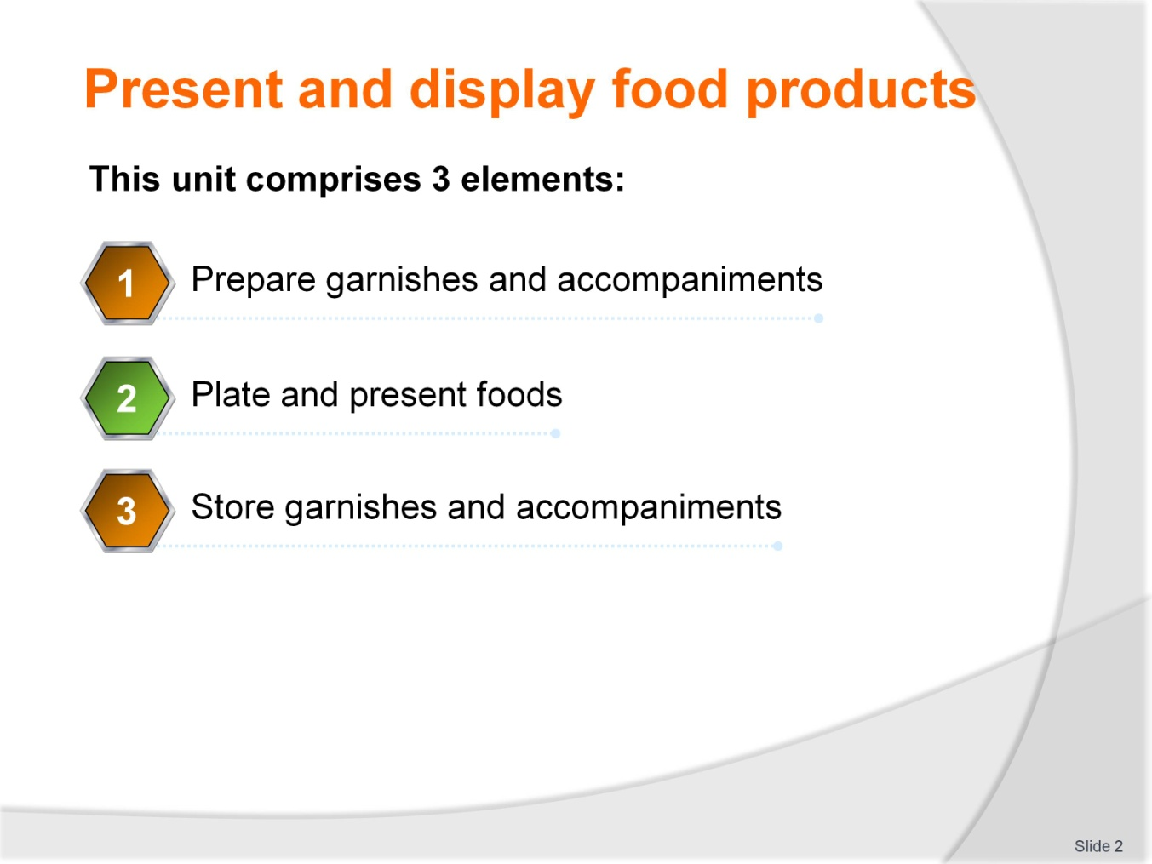
Slide No | Trainer Notes
Trainer advises students that this unit comprises 3 elements as listed on slide explaining:
Each element comprises several performance criteria
Students can obtain more information from the Trainee Manual
The course presents advice and information but, where their workplace requirements differ to what is presented, the workplace standards and practices must be observed.

Slide
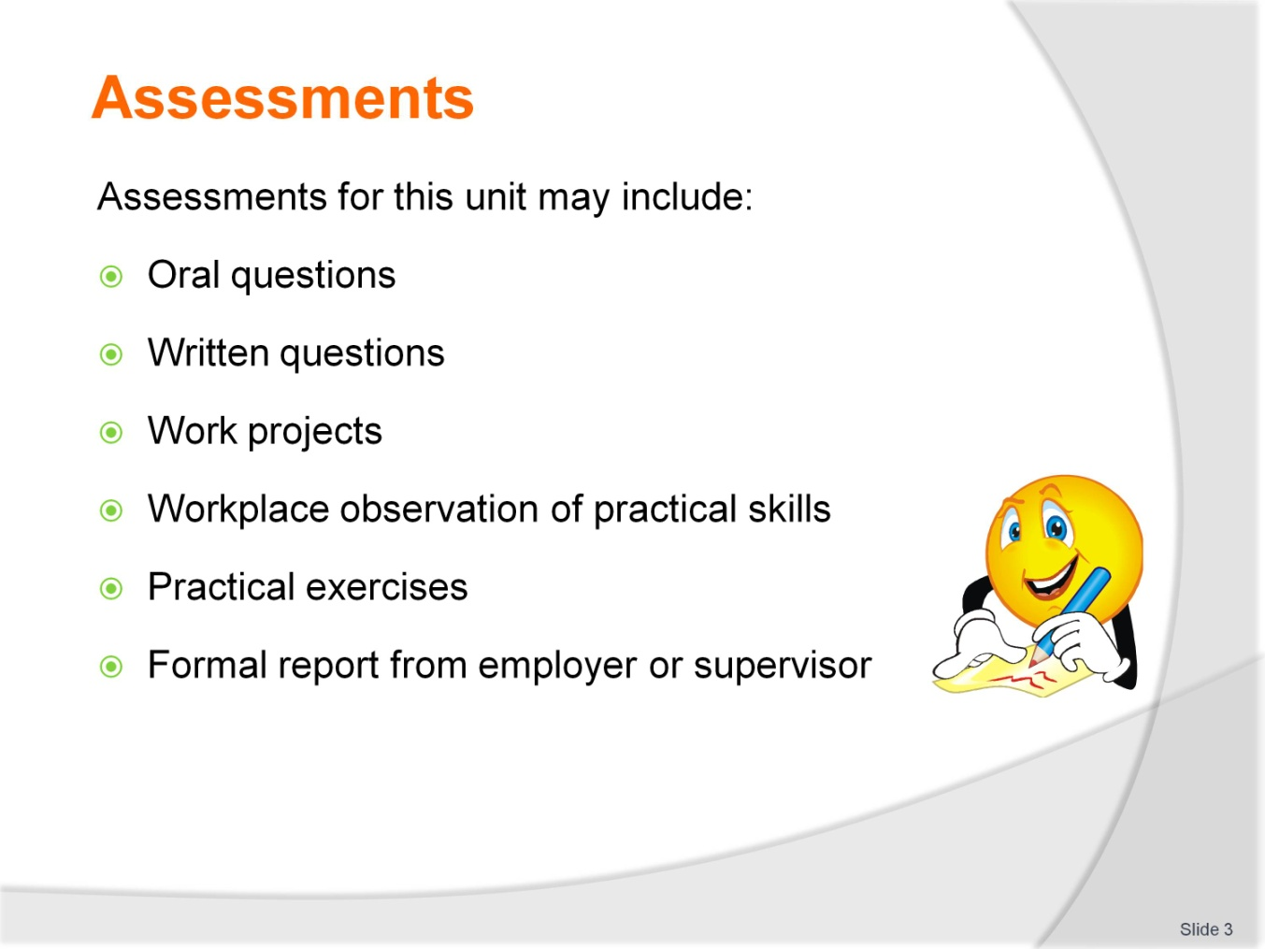
Slide No | Trainer Notes
Trainer advises students that assessment for this unit may take several forms, all of which are aimed at verifying that they have achieved competency for the unit as required
Trainer indicates to students the methods of assessment that will be applied to them for this particular unit.

Slide
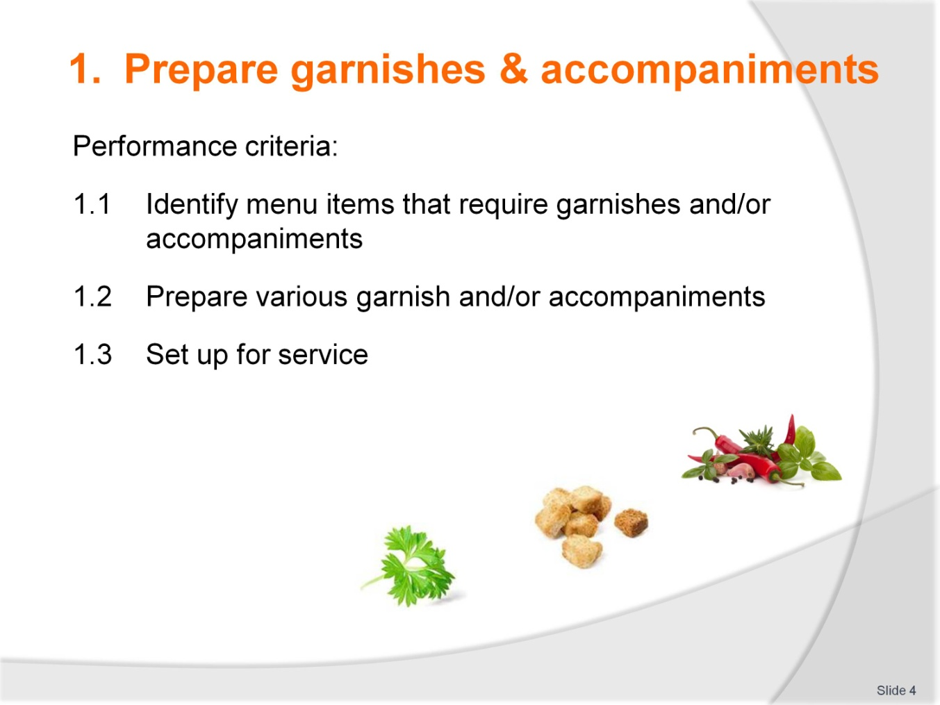
Slide No | Trainer Notes
 | Trainer explains each performance criteria for this element to students as listed on slide.

Slide
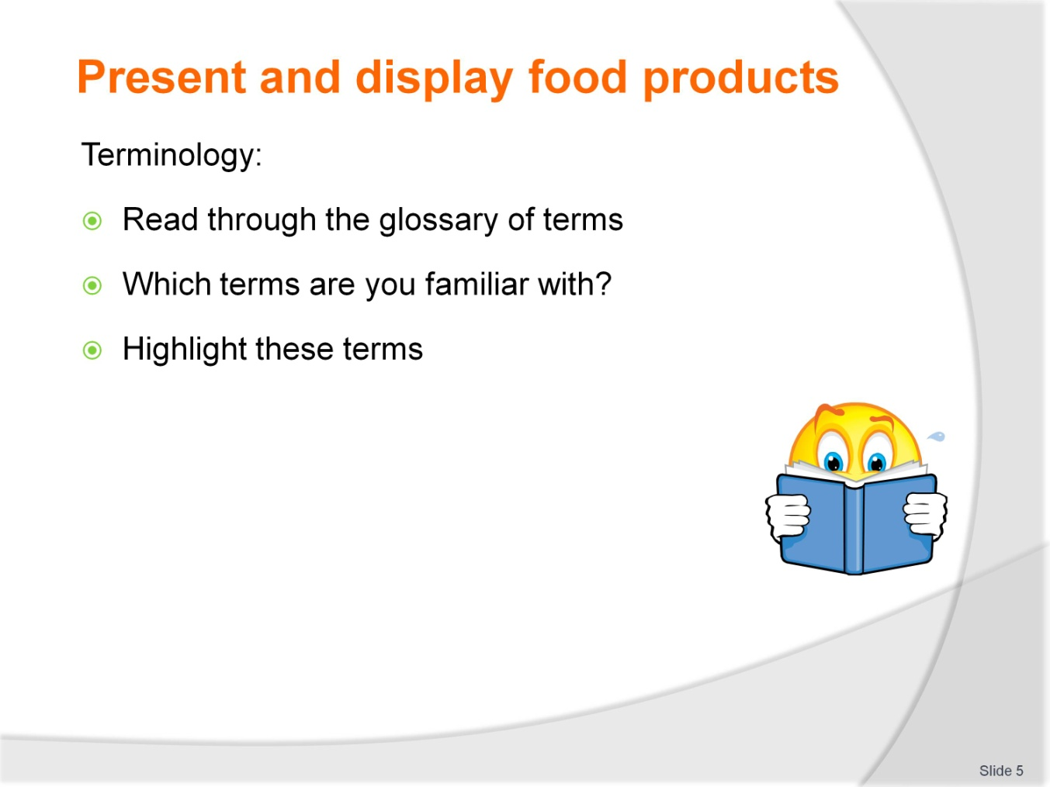
Slide No | Trainer Notes
Trainer to take students through glossary of terms in Trainee Manual.
Activity
Students to highlight any terms that they are familiar with.

Slide
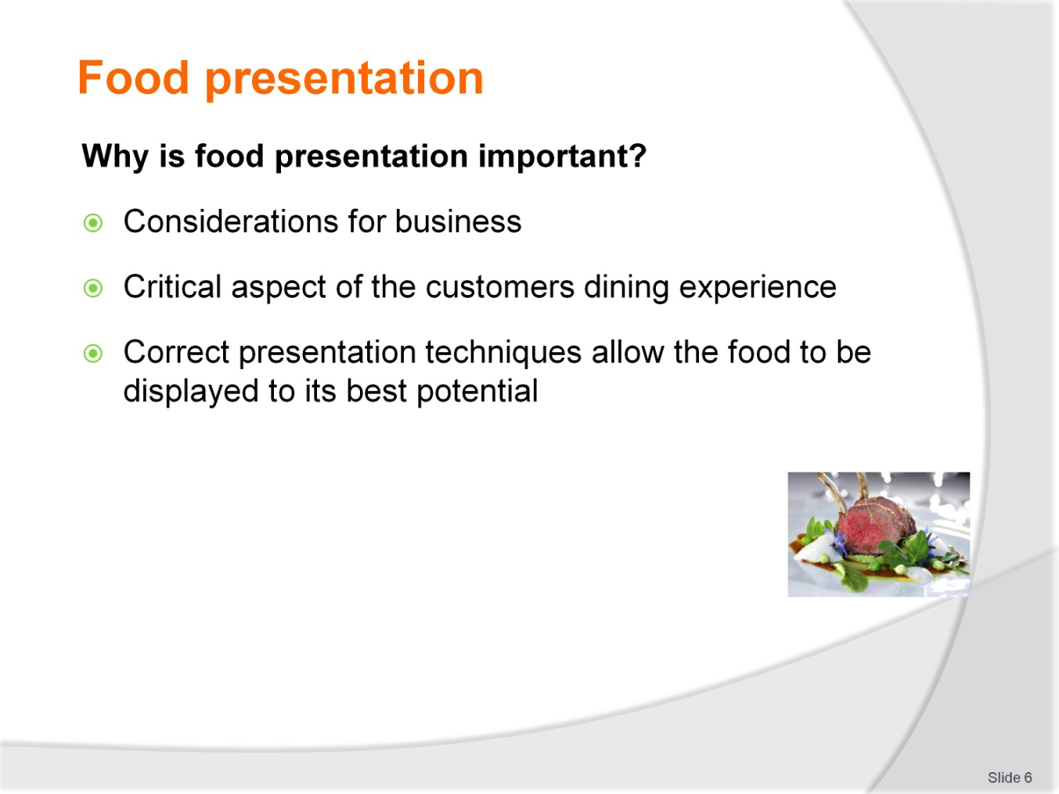
Slide No | Trainer Notes
Trainer to discuss food presentation and quality
Impact of good/bad presentation on the customer
Basics of food presentation.

Slide
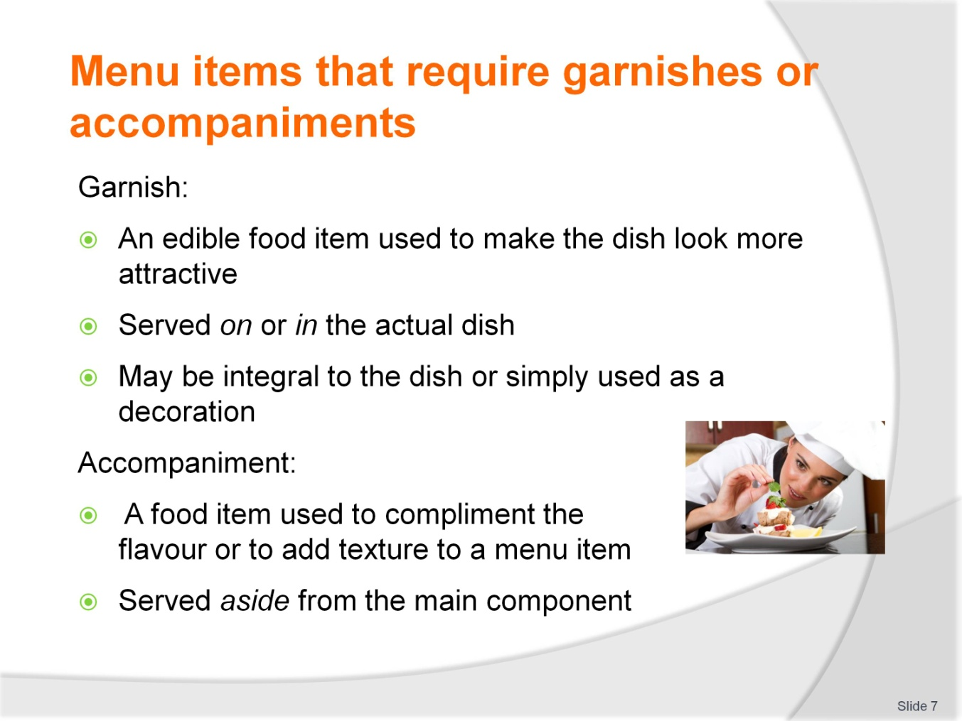
Slide No | Trainer Notes
Trainer to discuss/define the differences between a ‘garnish’ and an ‘accompaniment’
Trainer may give examples.

Slide
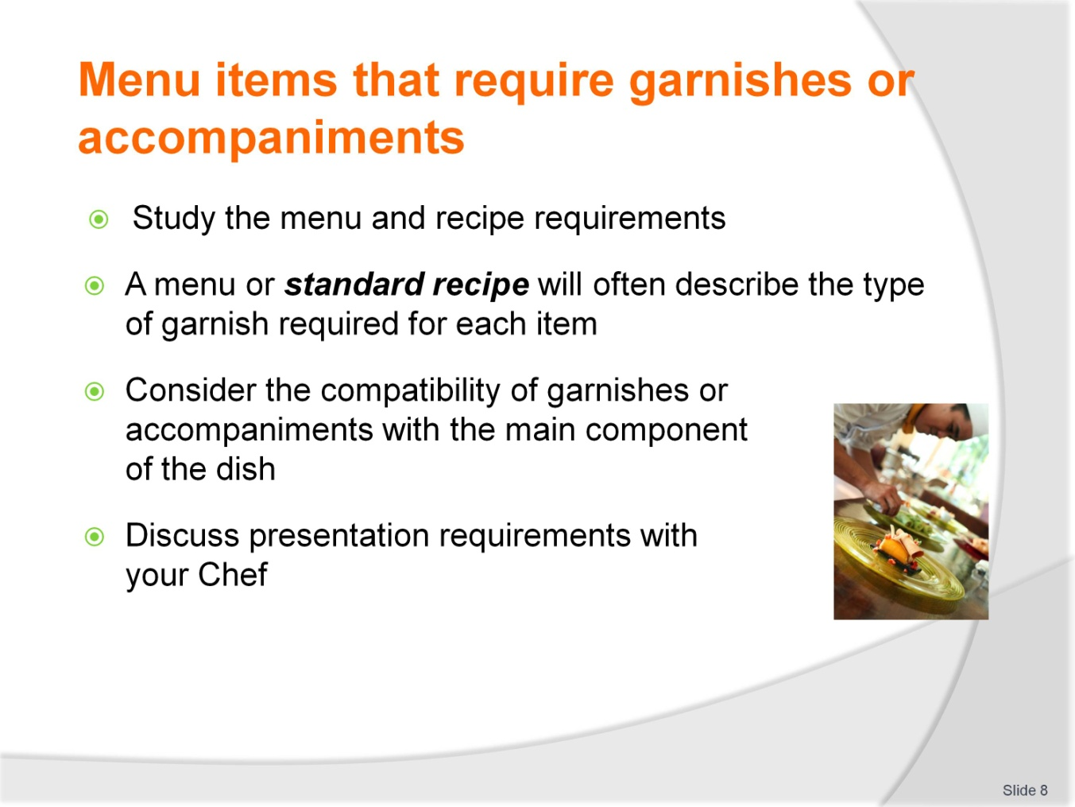
Slide No | Trainer Notes
Trainer outlines the various considerations for selecting garnishes and accompaniments for a variety of menu items
Outlines and defines a ‘standard recipe’, its implications and uses
Discusses compatibility of foods, flavours, colours and textures.

Slide
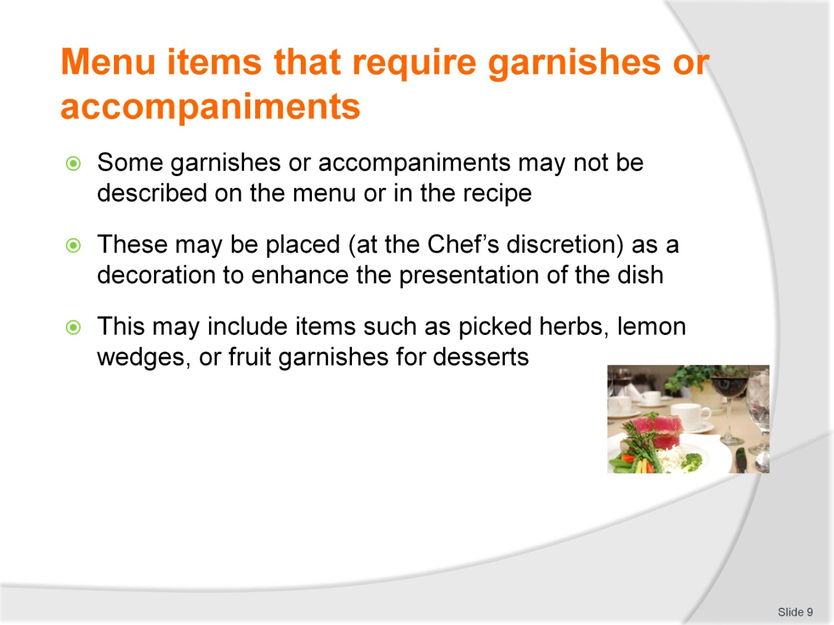
Slide No | Trainer Notes
 | Trainer discusses how some garnishes may not need to be described on the menu. Expectation of certain standard garnish or accompanying items.

Slide
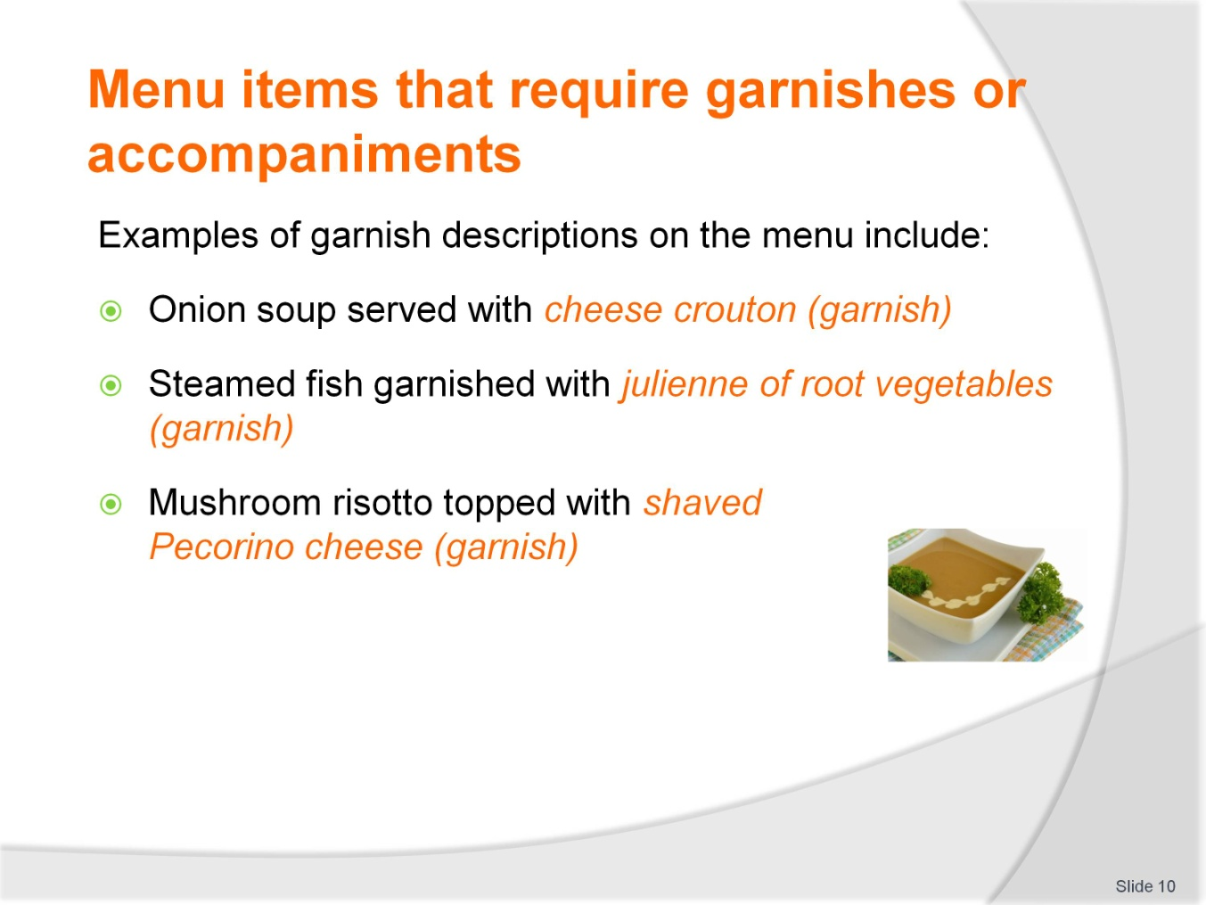
Slide No | Trainer Notes
Trainer provides these examples
Trainer seeks feedback from students on other (workplace) examples of garnishes described on menus.

Slide
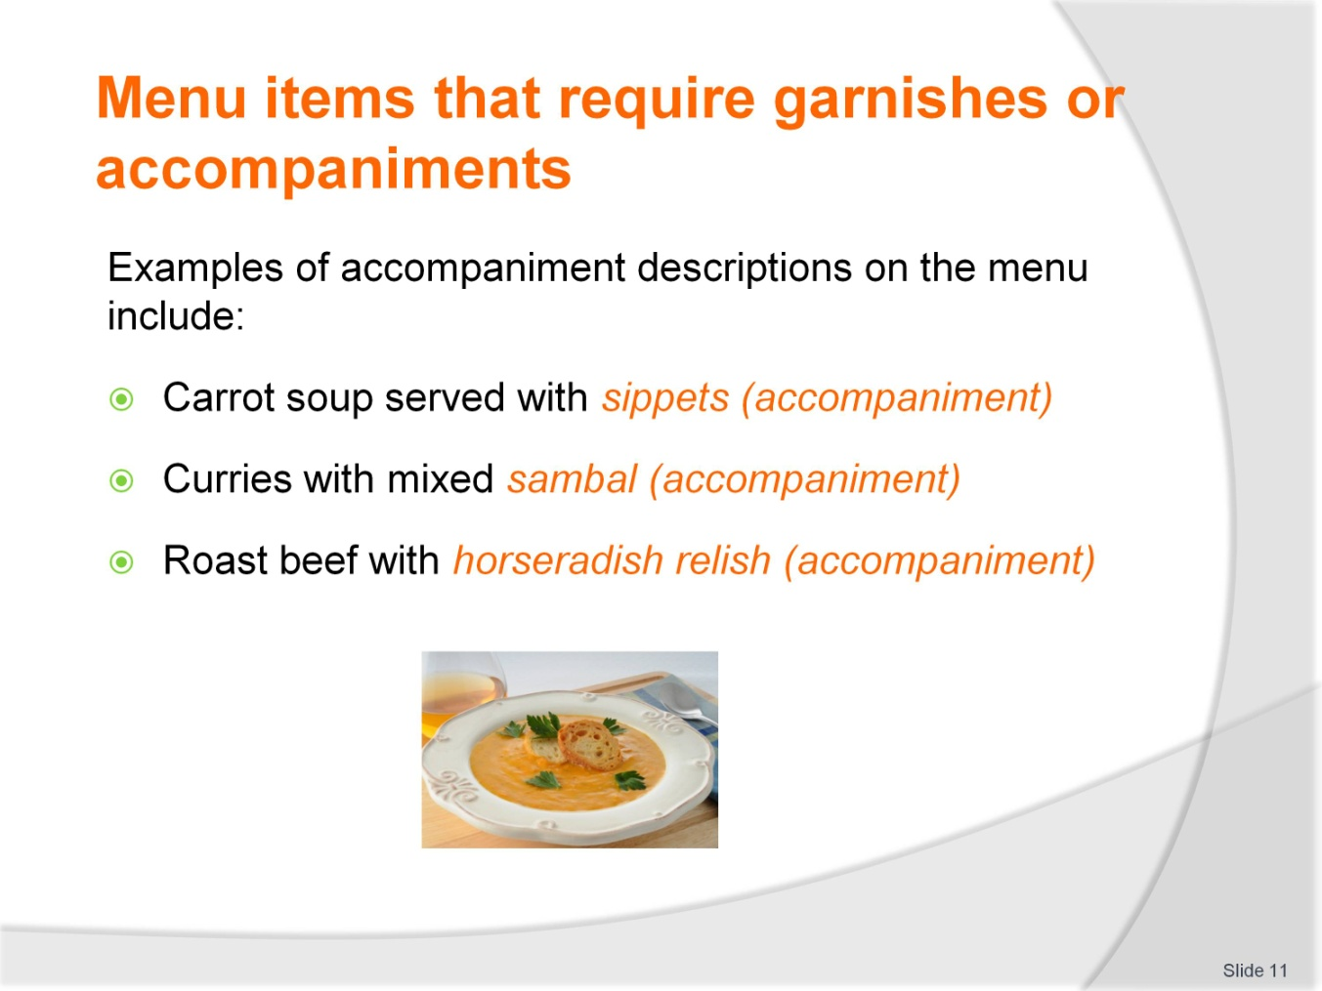
Slide No | Trainer Notes
Trainer provides these examples
Trainer seeks feedback from students on other (workplace) examples of accompaniments described on menus.

Slide
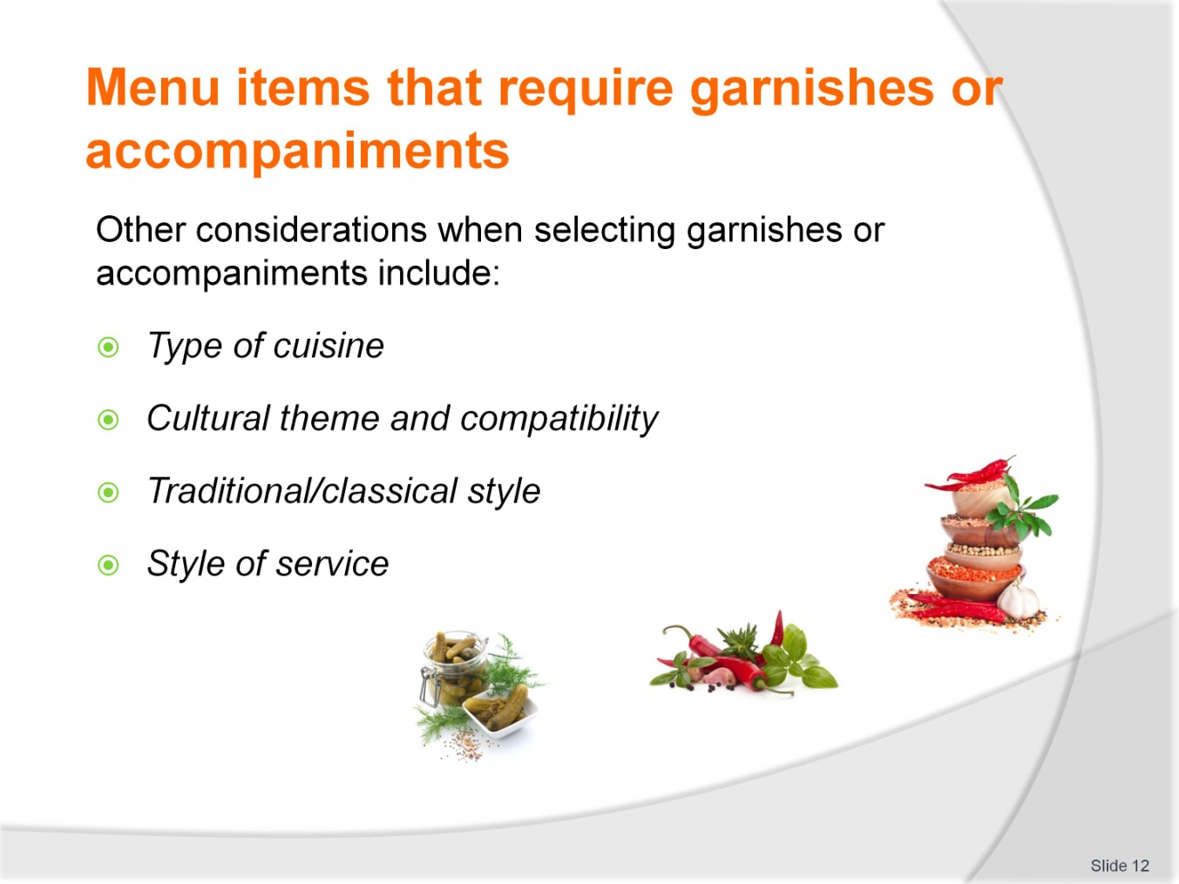
Slide No | Trainer Notes
Trainer outlines and explains each point in the slide and describes the importance of each consideration
Examples may include; rice as an accompaniment to most Asian cuisines, potatoes and pasta to European cuisines.

Slide
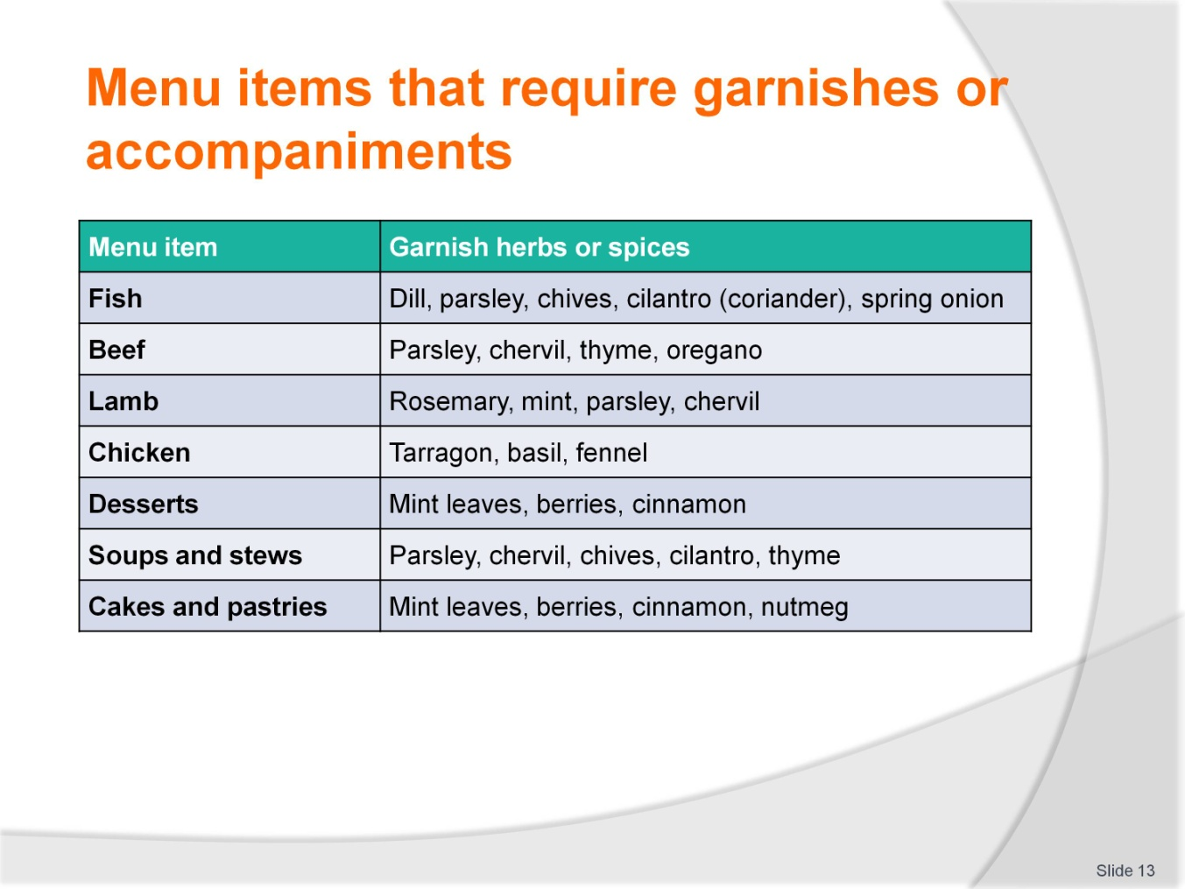
Slide No | Trainer Notes
Trainer may explain compatibility/incompatibility of flavours, traditional flavour partners to foods
Explain that this list is not comprehensive but gives a good indicator of appropriate garnish herbs/spices
May explain the difference between presenting inappropriate items with certain foods (i.e. rosemary with fish or Asian garnish herbs with traditional European cuisine).

Slide
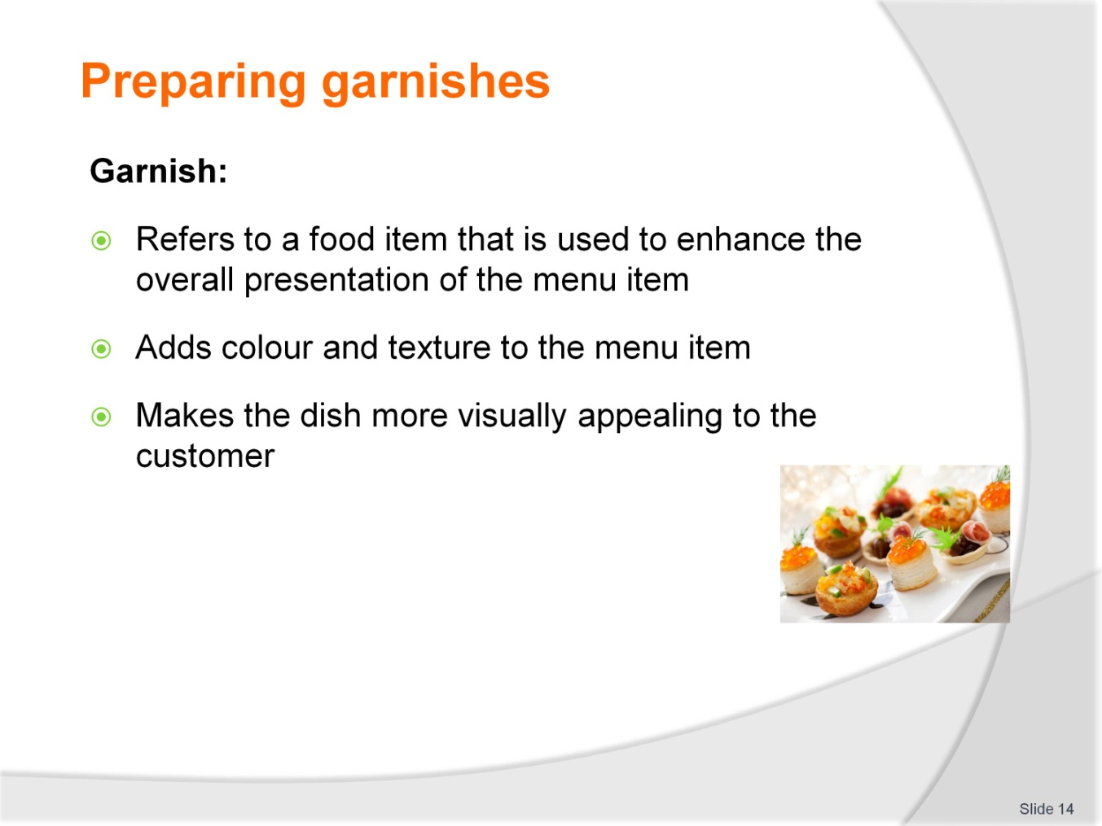
Slide No | Trainer Notes
 | Trainer defines a ‘garnish’ and its uses.

Slide
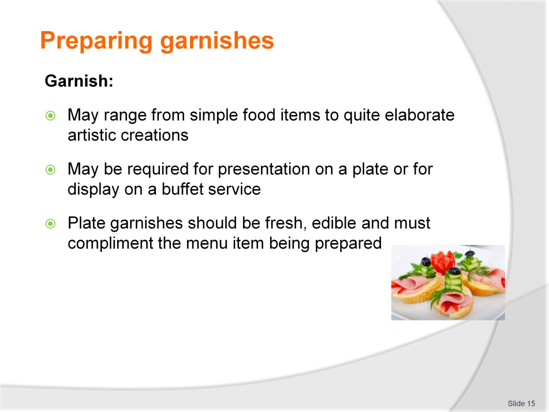
Slide No | Trainer Notes
 | Trainer defines a ‘garnish’ and its uses.

Slide
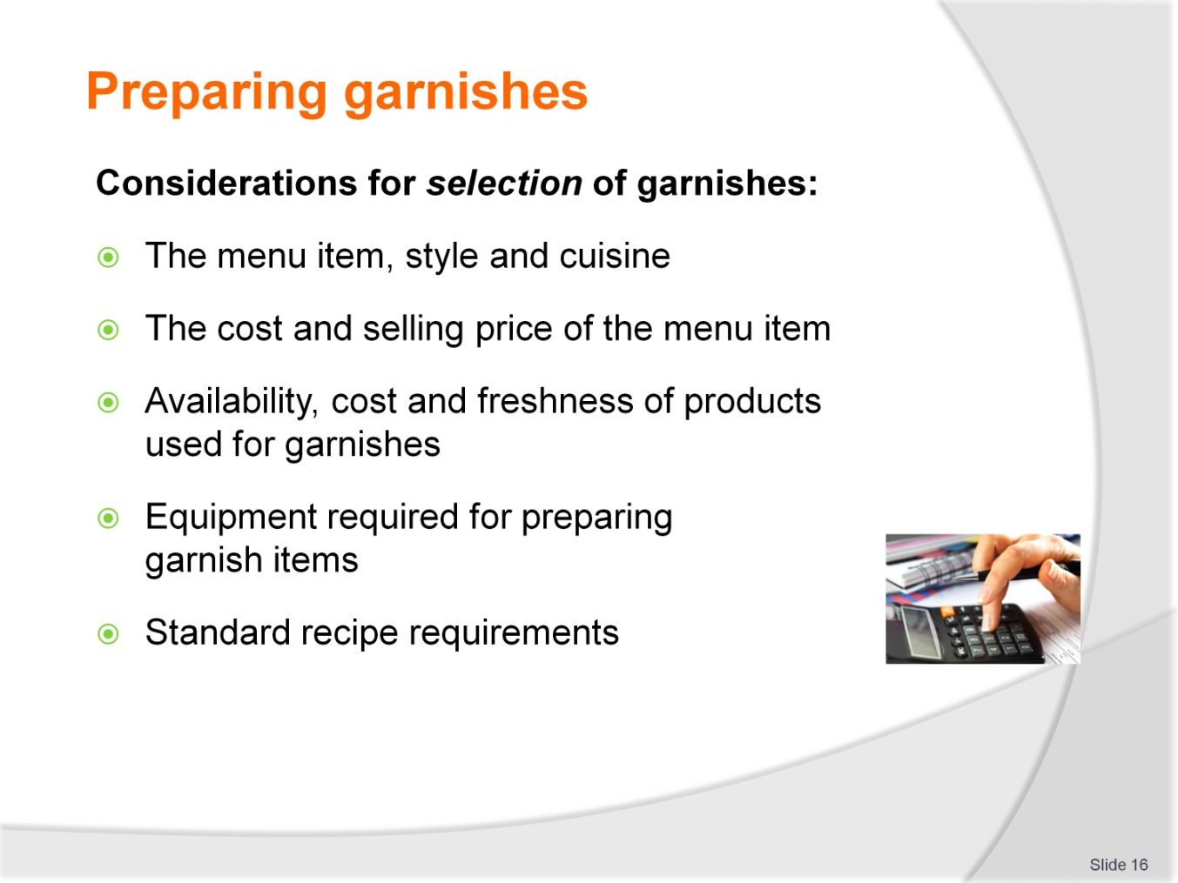
Slide No | Trainer Notes
 | Trainer outlines how garnishes are selected and consideration for selection.

Slide
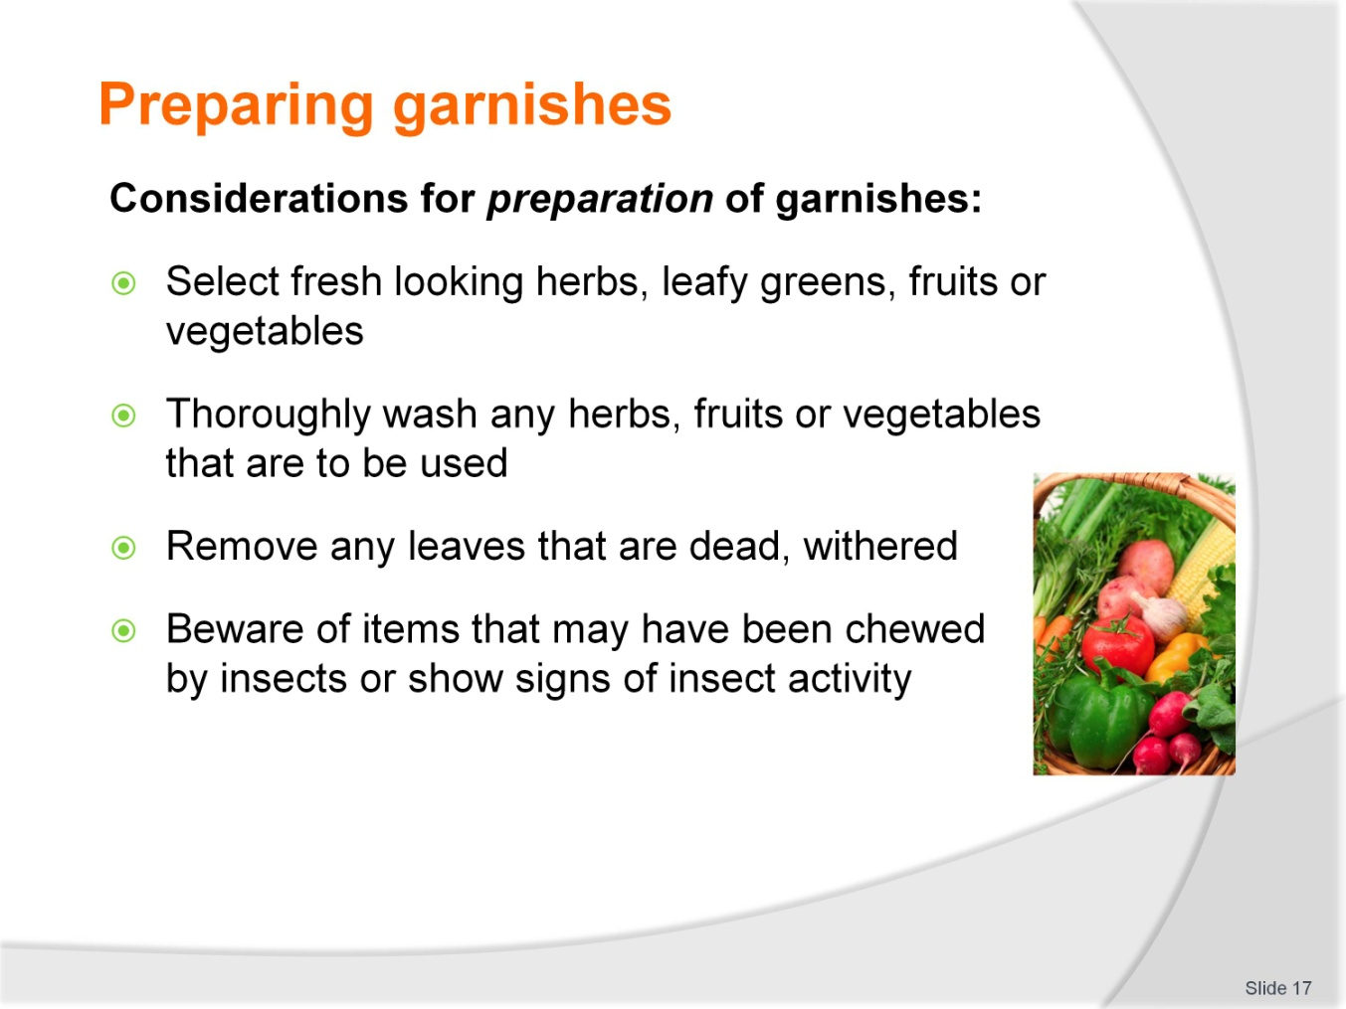
Slide No | Trainer Notes
 | Trainer outlines how garnishes are selected and consideration for selection.

Slide
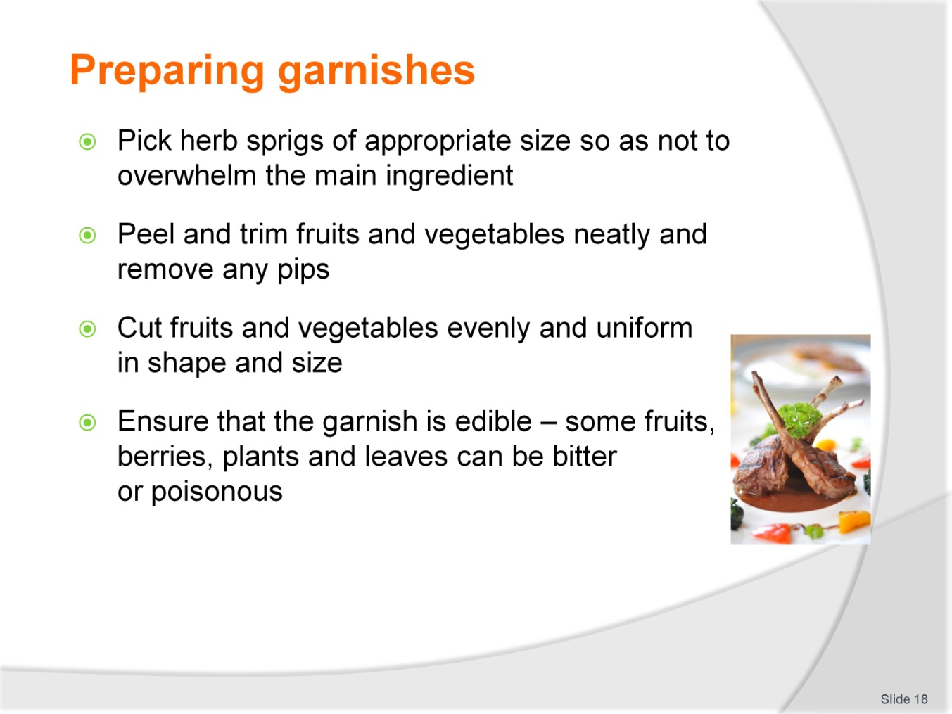
Slide No | Trainer Notes
 | Trainer outlines how garnishes are prepared to quality standards.

Slide
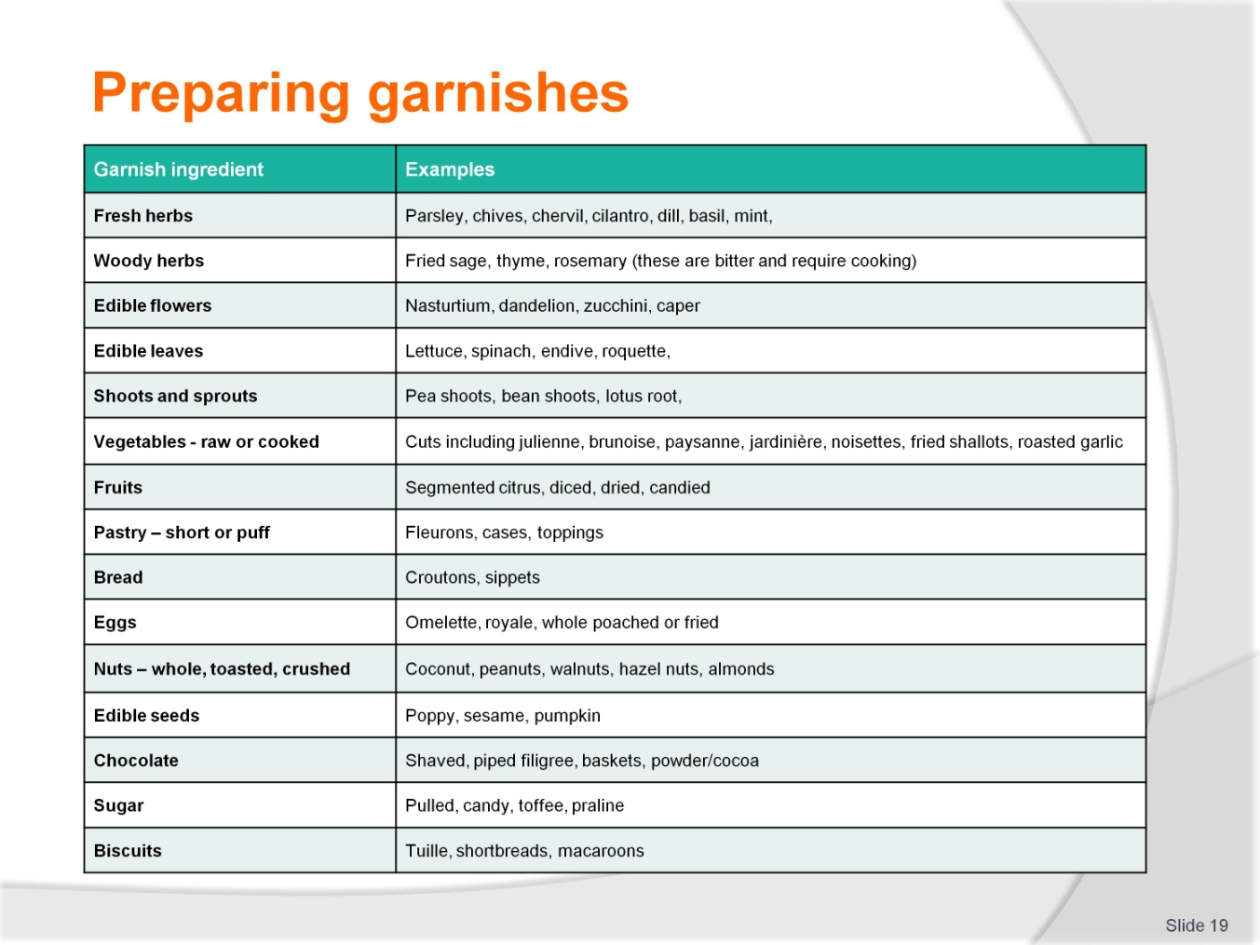
Slide No | Trainer Notes
 | Trainer gives overview from table defining different garnish items and categories.

Slide
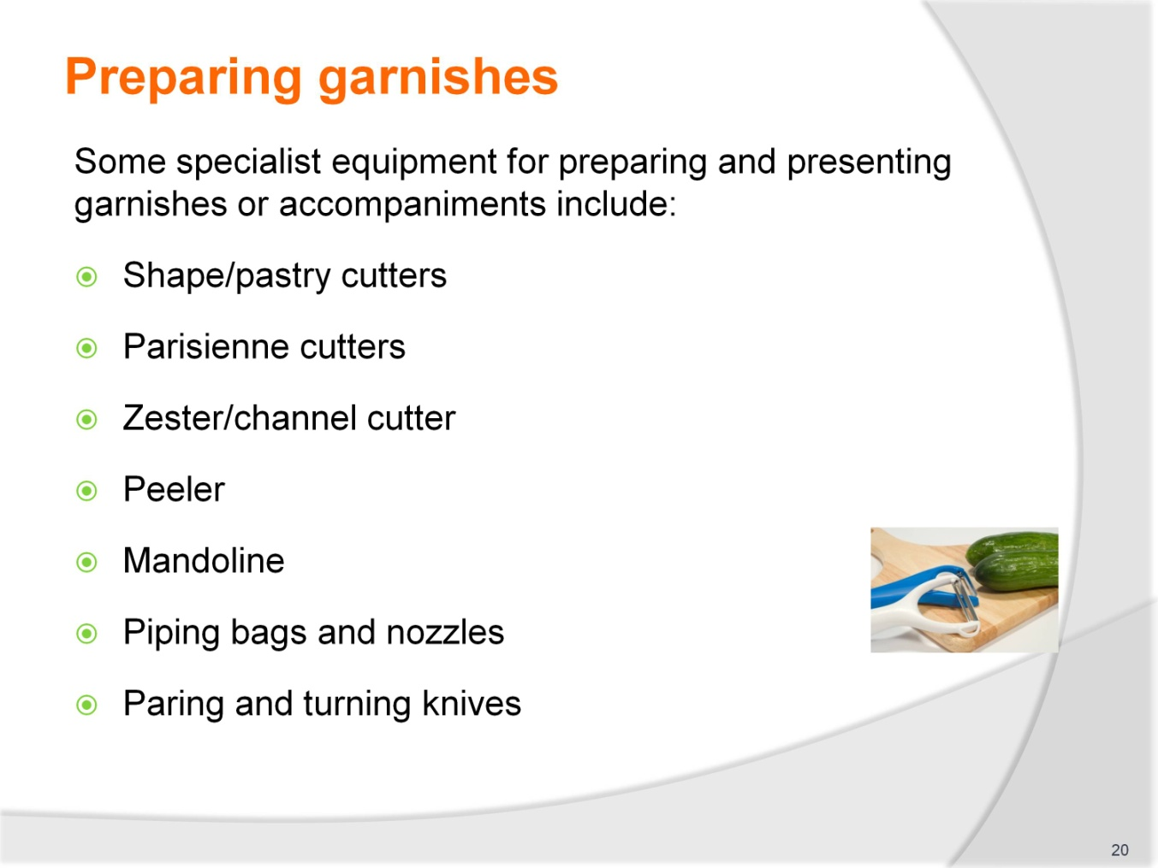
Slide No | Trainer Notes
 | Trainer describes selection and use of a variety of equipment used to prepare and shape garnishes.

Slide
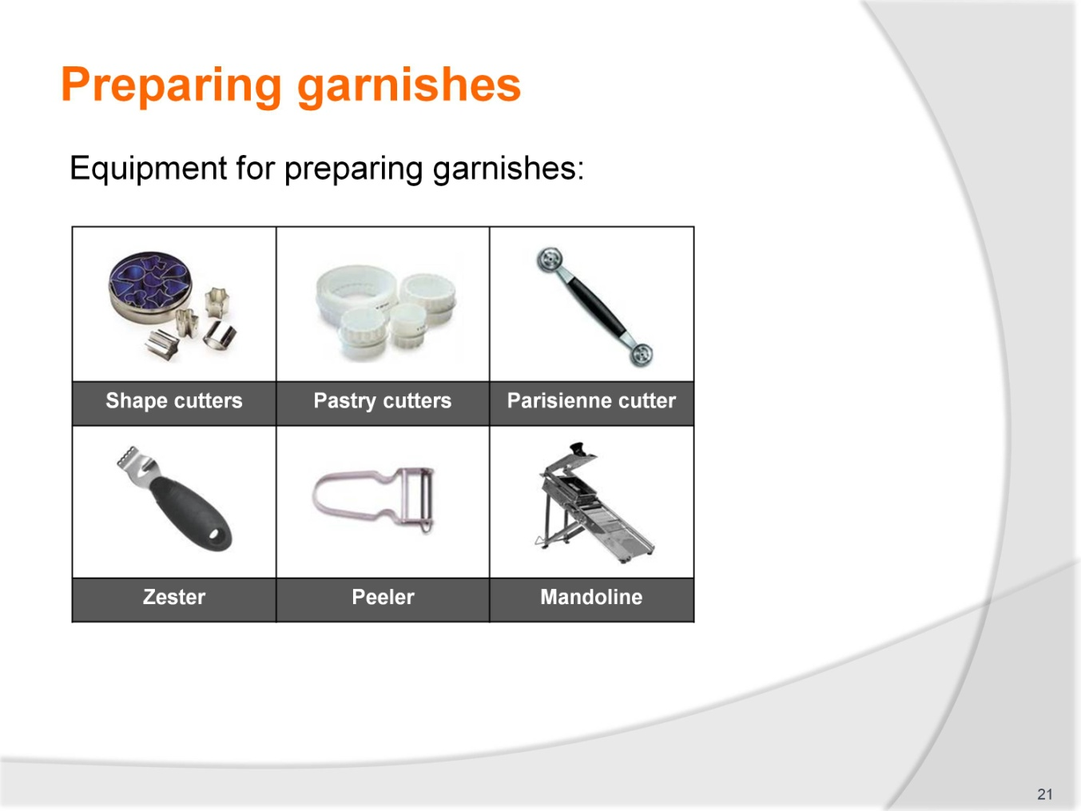
Slide No | Trainer Notes
 | Trainer describes the use of each pictured item.

Slide
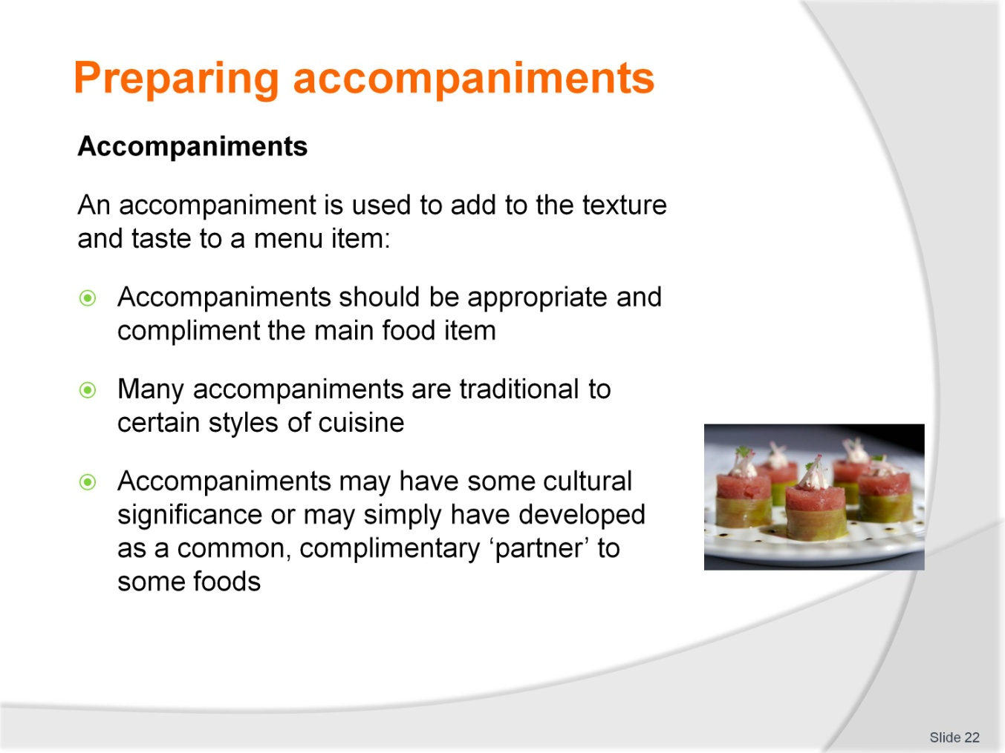
Slide No | Trainer Notes
 | Trainer defines an ‘accompaniment’ from the listed points.

Slide
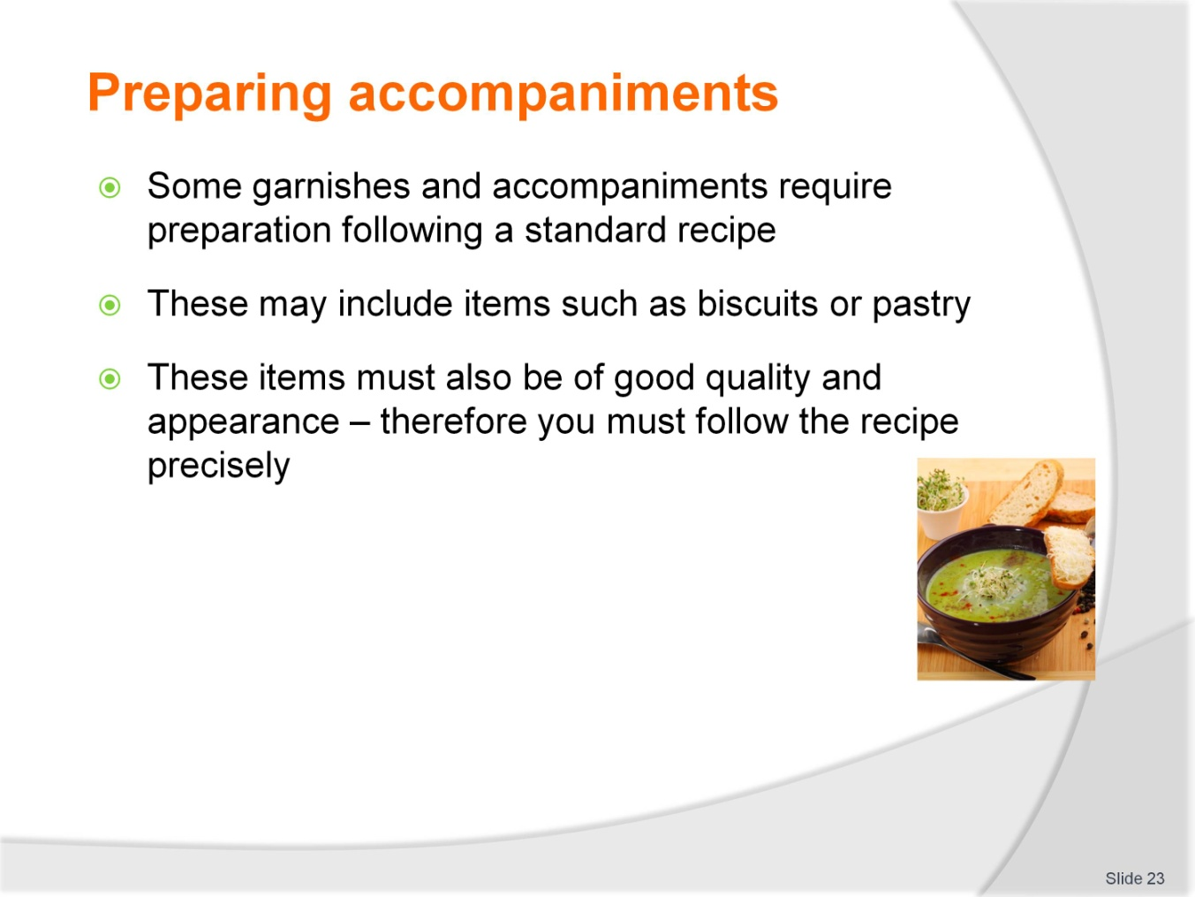
Slide No | Trainer Notes
 | Trainer defines an ‘accompaniment’ and uses from the listed points.

Slide
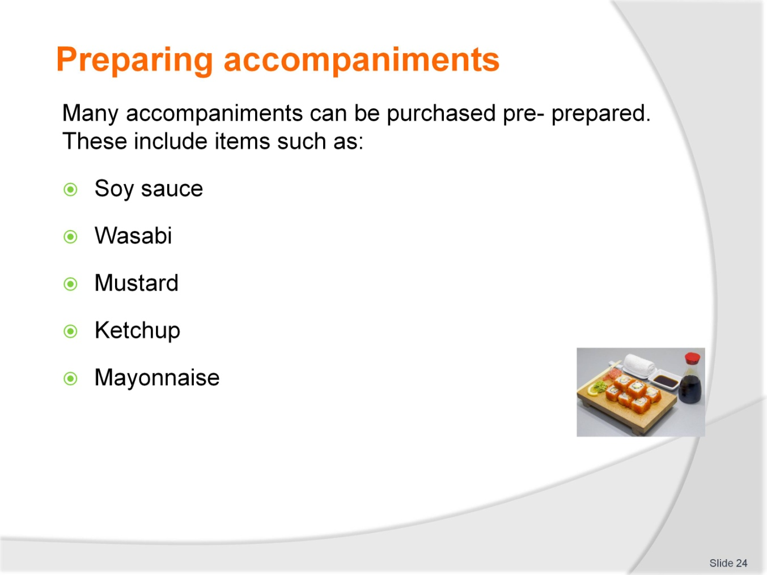
Slide No | Trainer Notes
 | Trainer defines prepared accompaniments from the listed points.

Slide
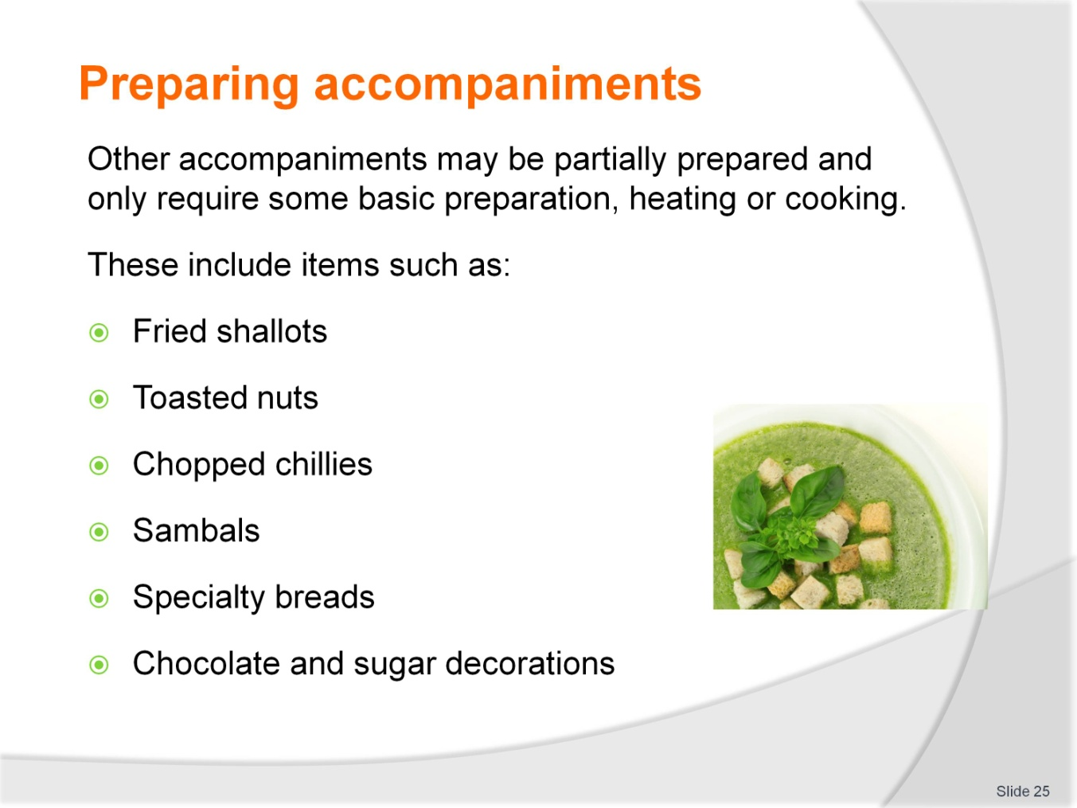
Slide No | Trainer Notes
 | Trainer defines prepared accompaniments from the listed points. May discuss cultural or specific cuisines for accompaniments.

Slide
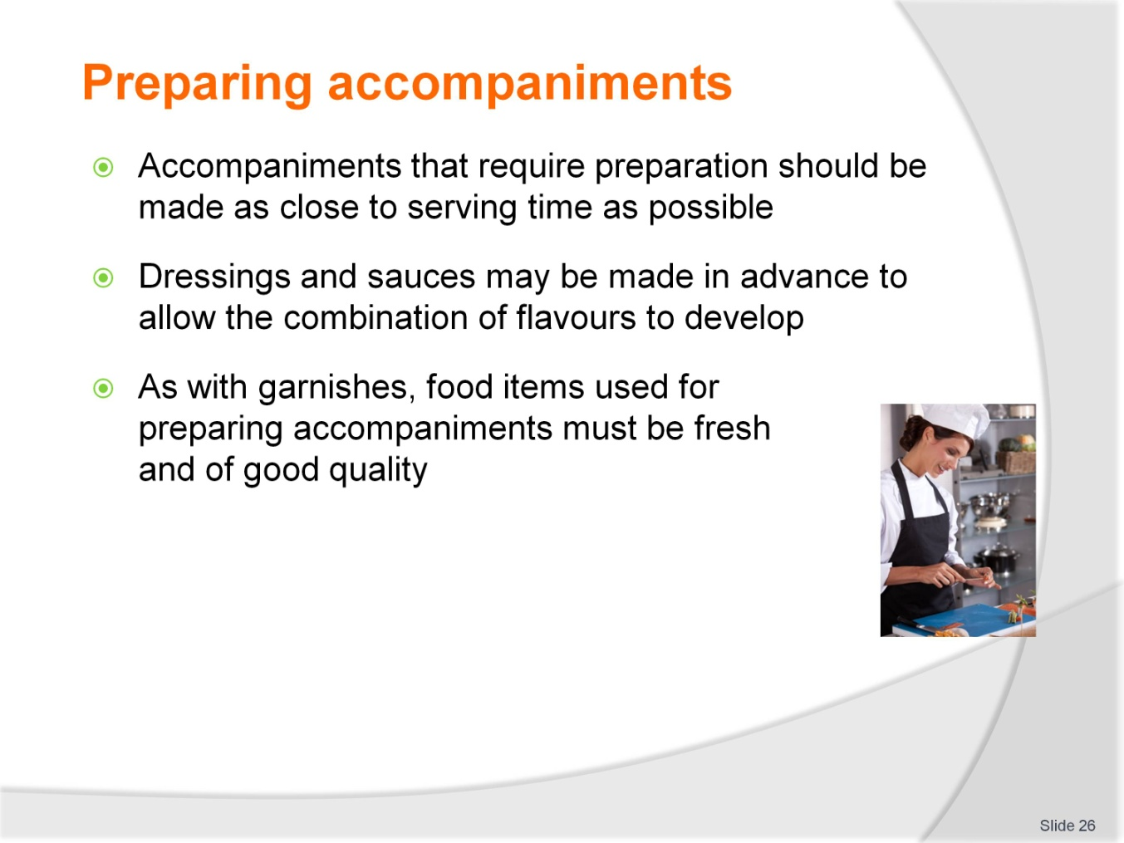
Slide No | Trainer Notes
 | Trainer describes quality points in preparing fresh accompaniments.

Slide
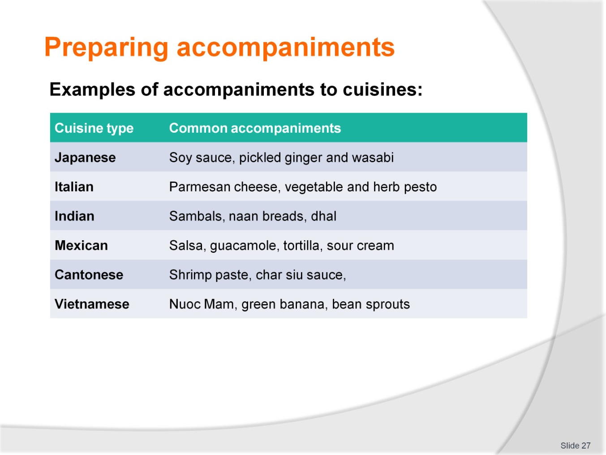
Slide No | Trainer Notes
 | Trainer discusses different cuisines and traditional accompaniments using table.

Slide
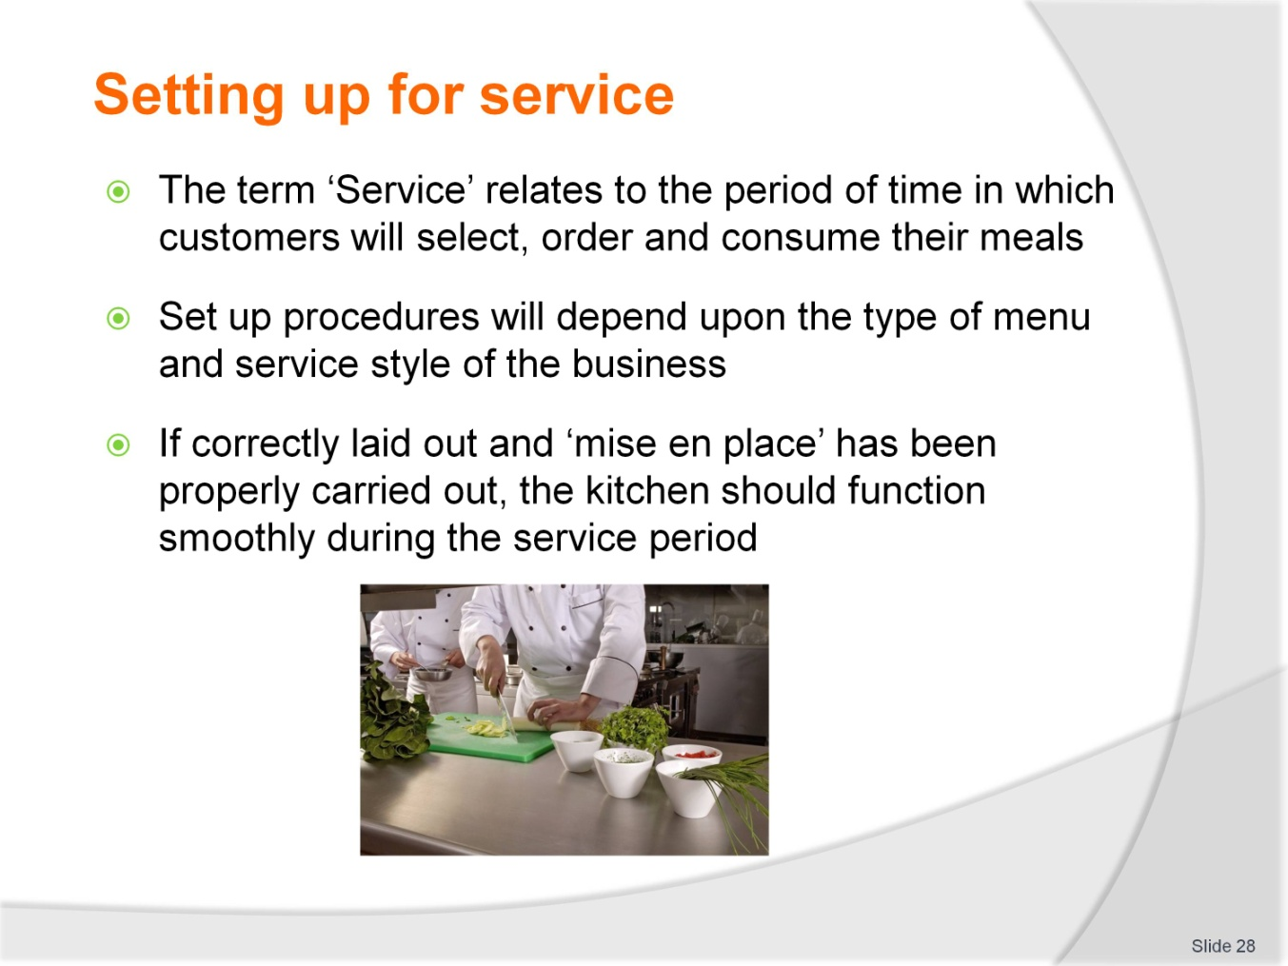
Slide No | Trainer Notes
 | Describe the term ‘service’ and how this relates to overall food presentation. Briefly describe types of menus and service styles.

Slide
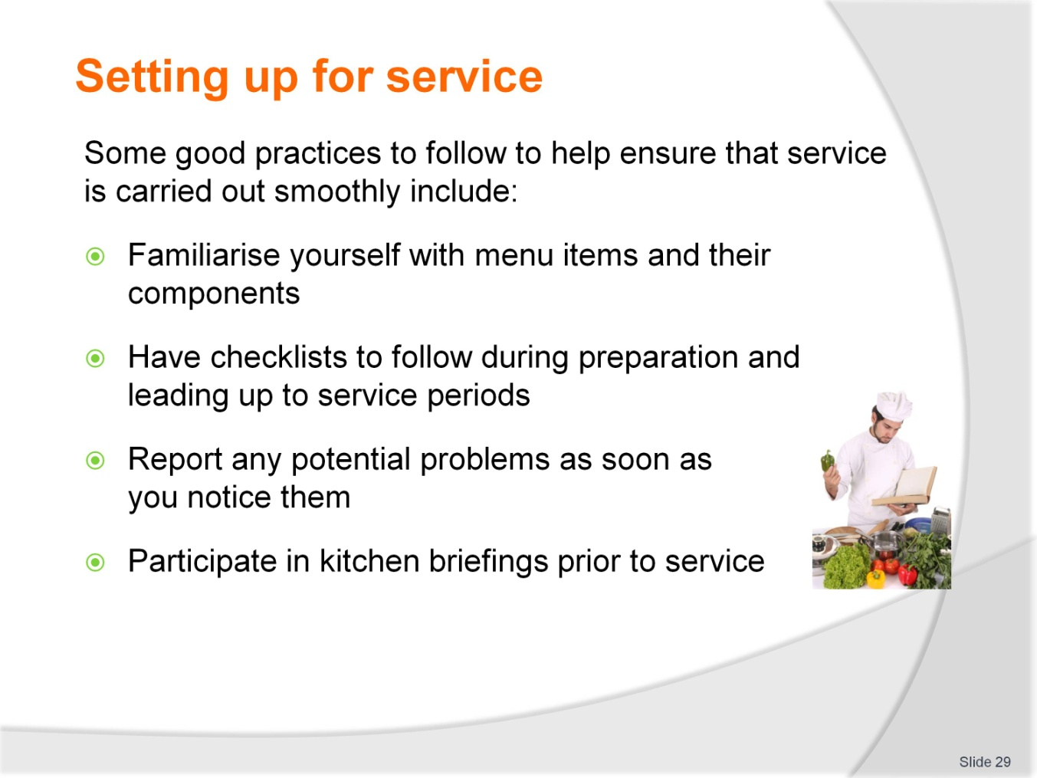
Slide No | Trainer Notes
 | Describe procedures to ensure that service is carried out to minimise mistakes or problems prior to and during service.

Slide
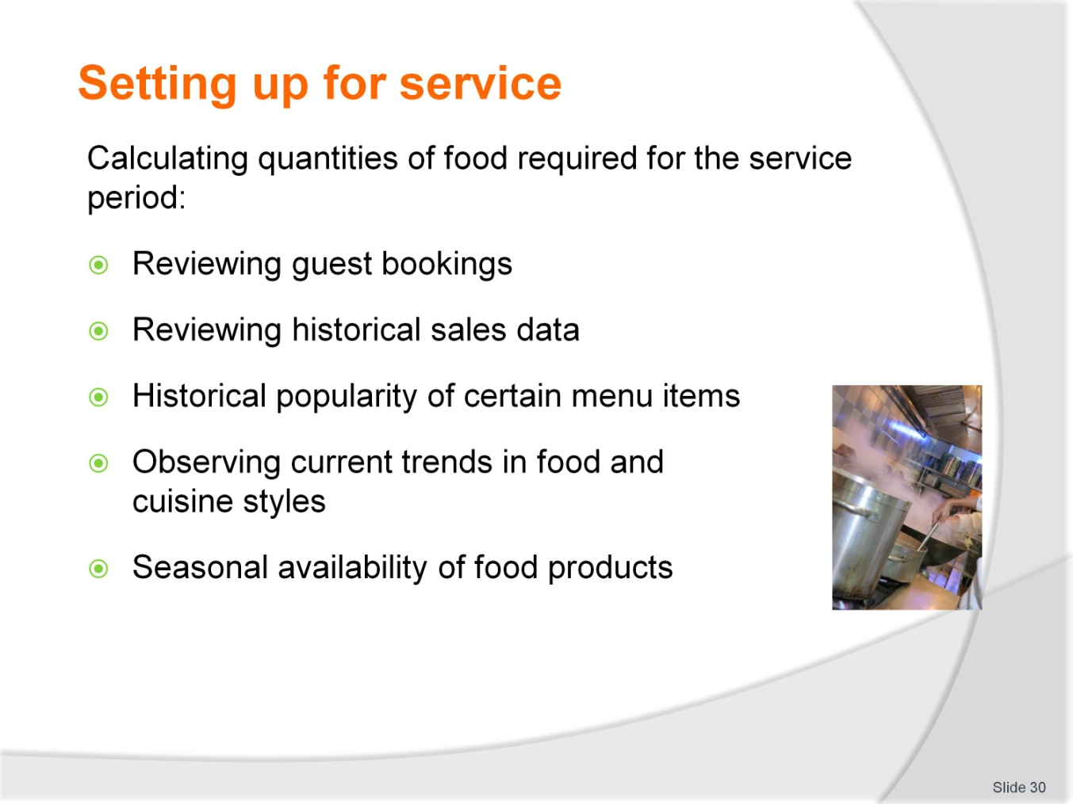
Slide No | Trainer Notes
 | Discuss the importance of calculating food quantities required for food service. Elaborate on each point in the slide.

Slide
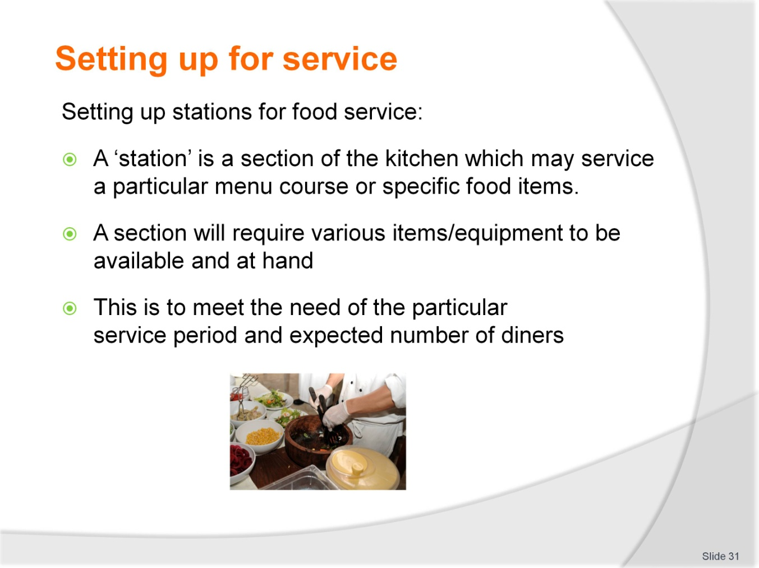
Slide No | Trainer Notes
Give an overview of the term ‘station’
Describe the different stations in a kitchen and how they interact.

Slide
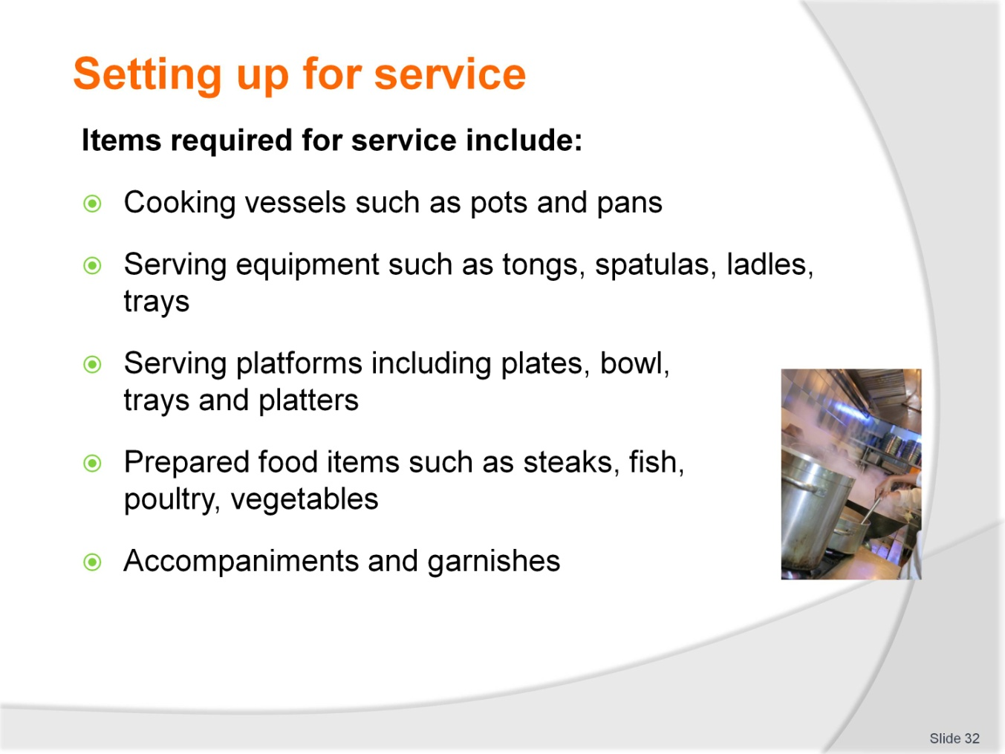
Slide No | Trainer Notes
Outline the various considerations for setting up for service using points in slide
Describes why these points are critical to smooth workflow and minimising errors during service periods.

Slide
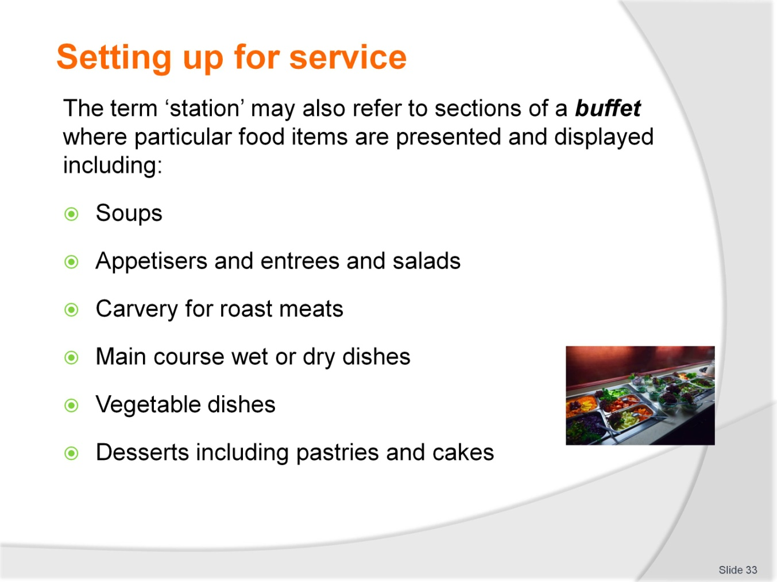
Slide No | Trainer Notes
Define the term ‘station’ as it relates to the buffet style of service
May draw up an outline of a buffet set up showing patron flow and describing its importance.

Slide
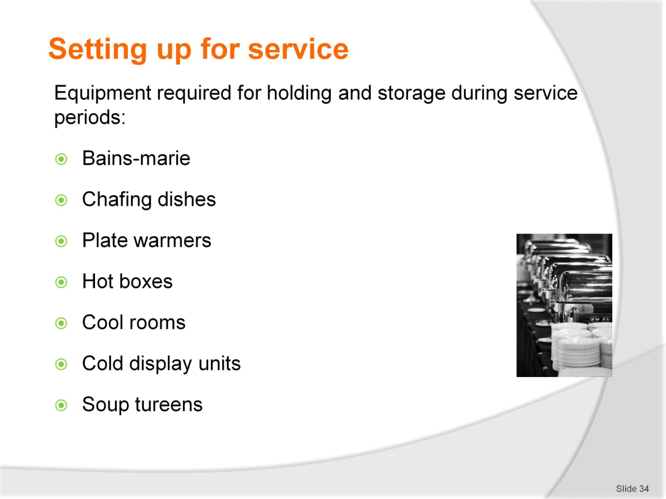
Slide No | Trainer Notes
Give an outline of equipment used for the holding and storage of food items during service
Define which item would suit each service style.

Slide
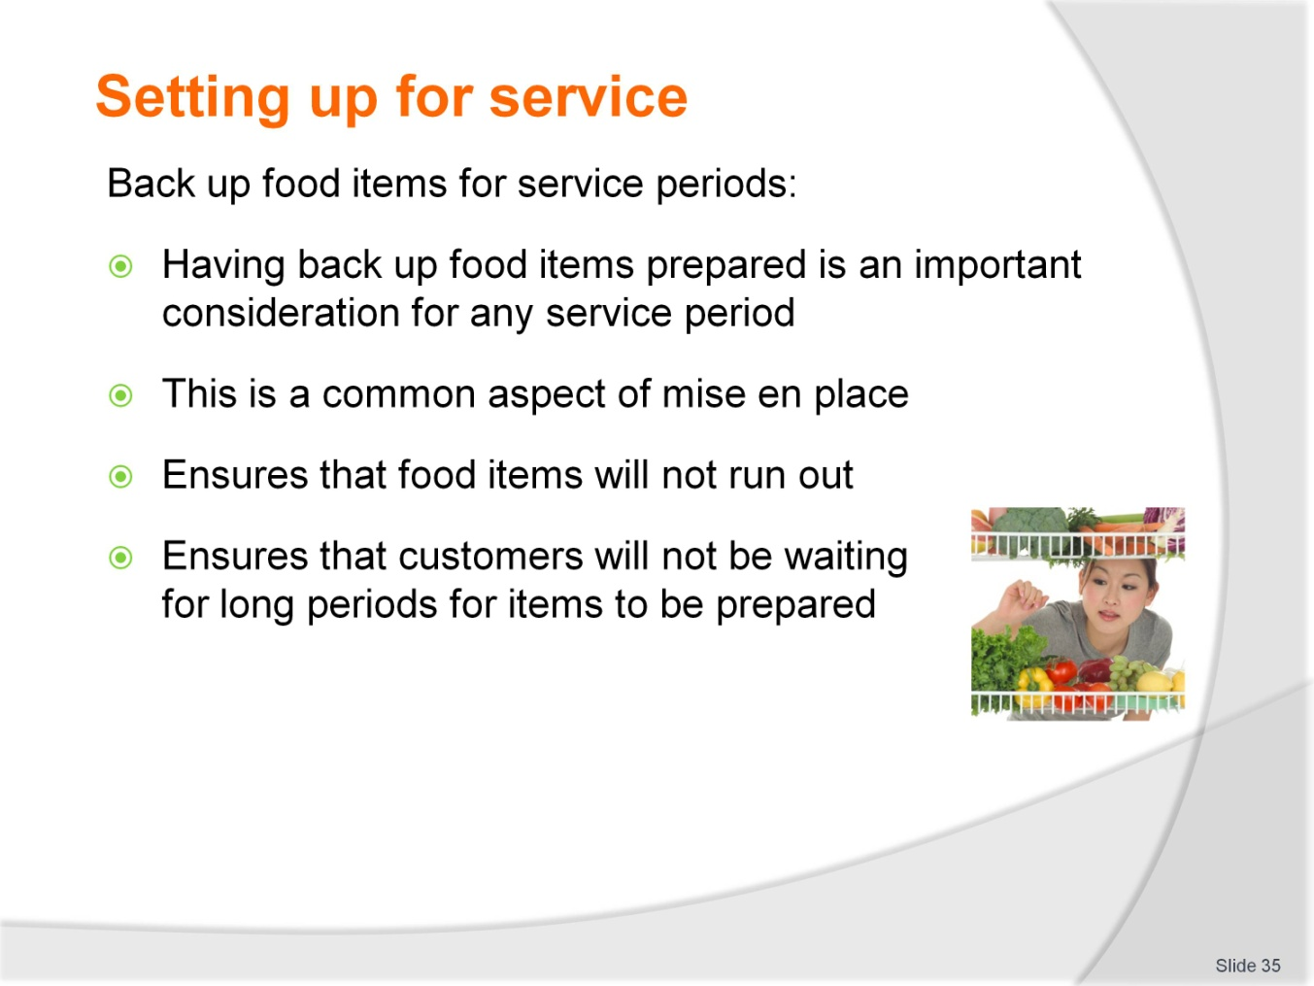
Slide No | Trainer Notes
From points in slide, define the term ‘back up’
Describe the importance in relation to customer service and quality standards.

Slide
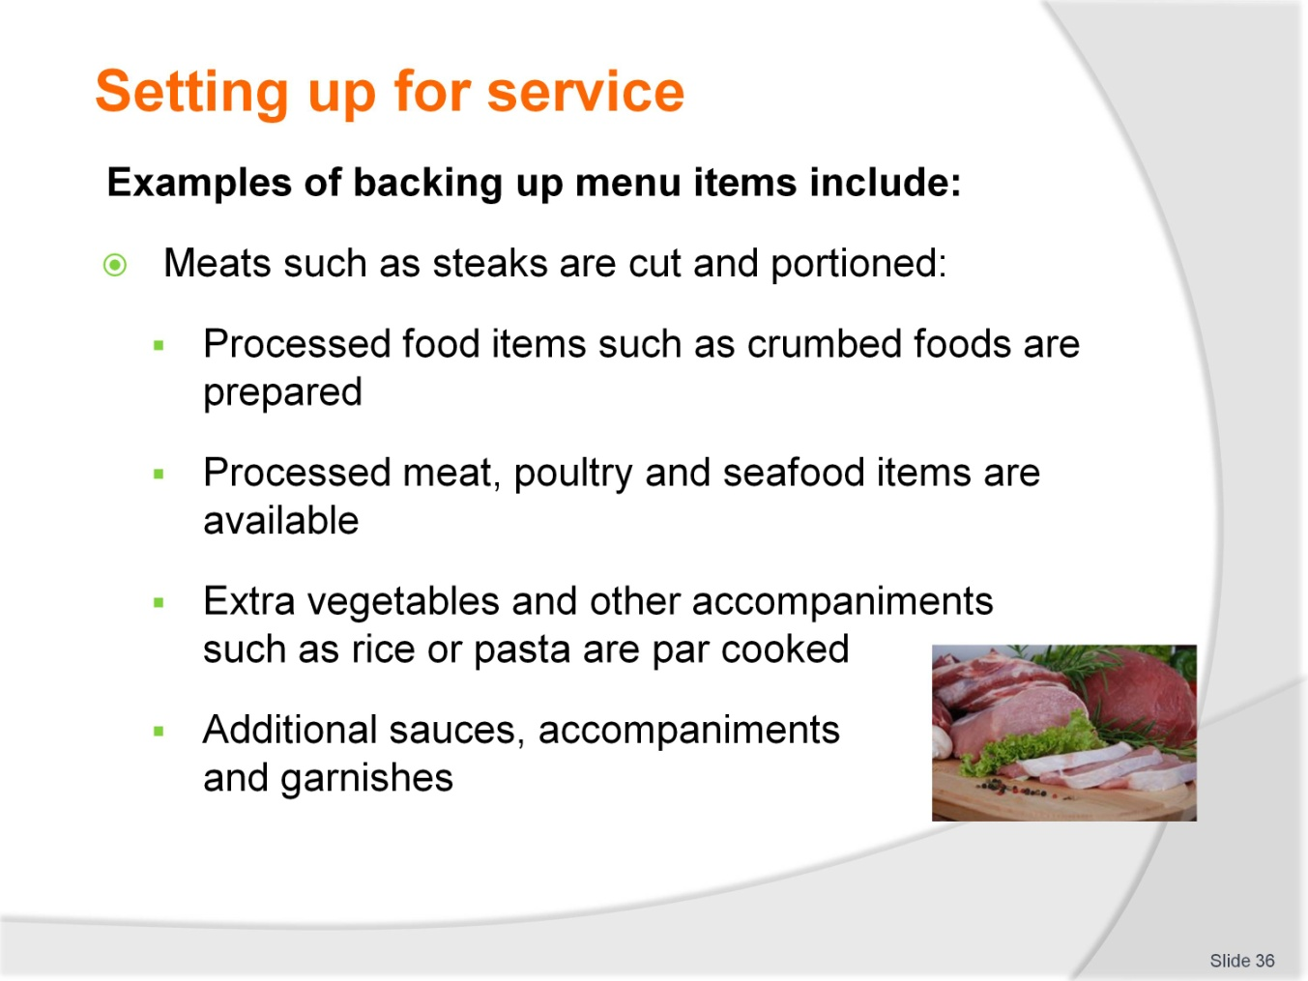
Slide No | Trainer Notes
Read through the points in slide
Seek feedback/examples from students.

Slide
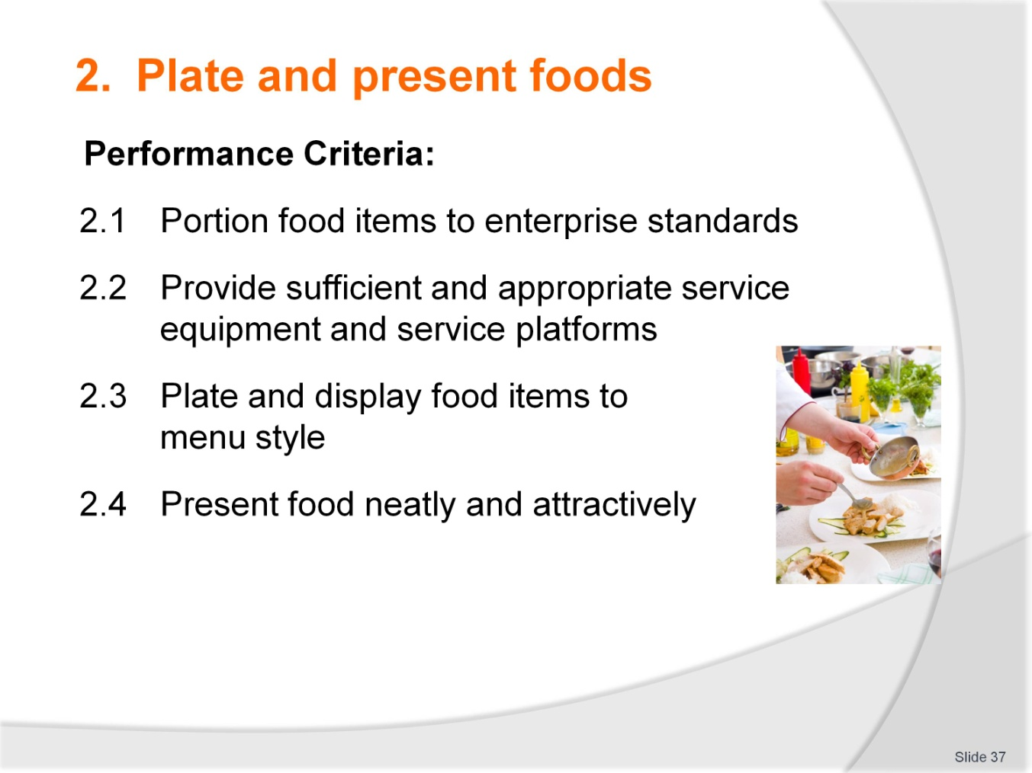
Slide No | Trainer Notes
 | Outline to students the second element and its performance criteria.

Slide
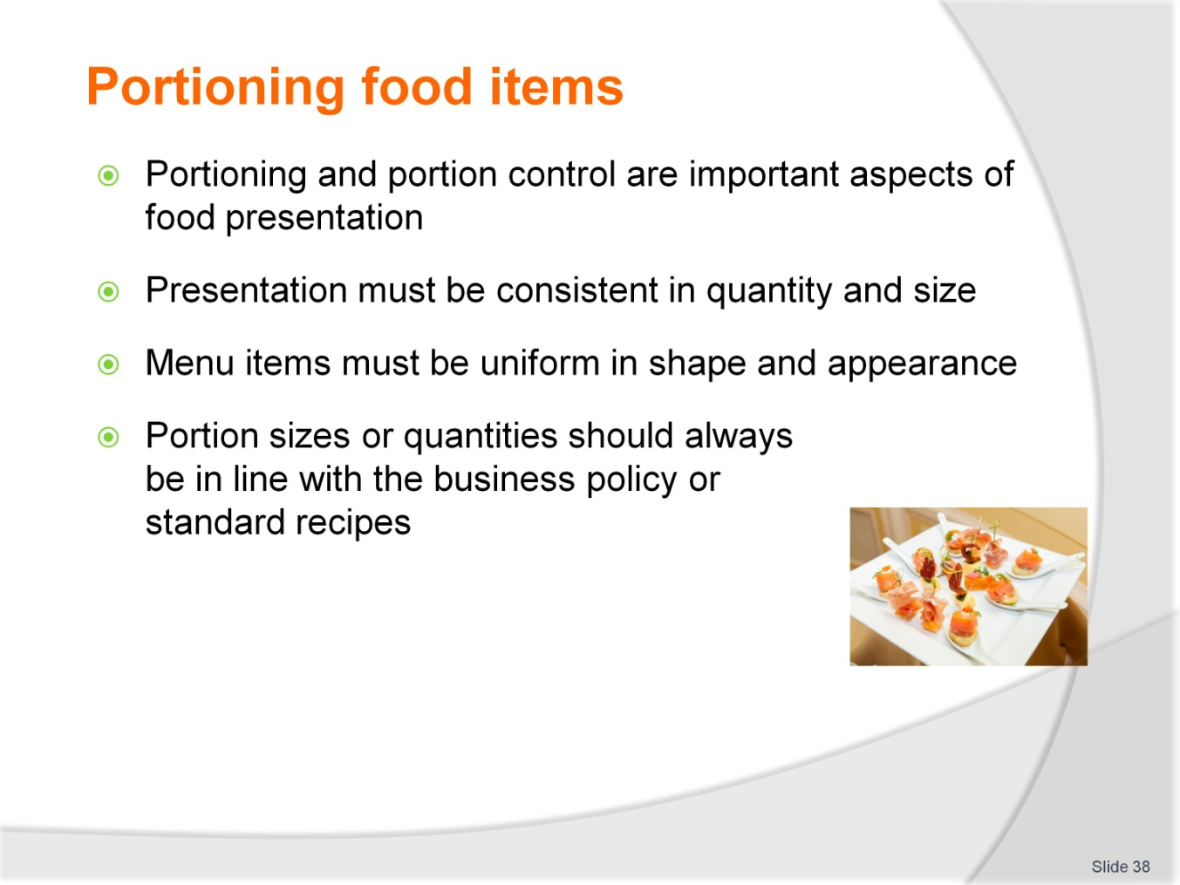
Slide No | Trainer Notes
Define the terms ‘portion’ and ‘portion control’
Describe the importance of consistency using the points in slide.

Slide
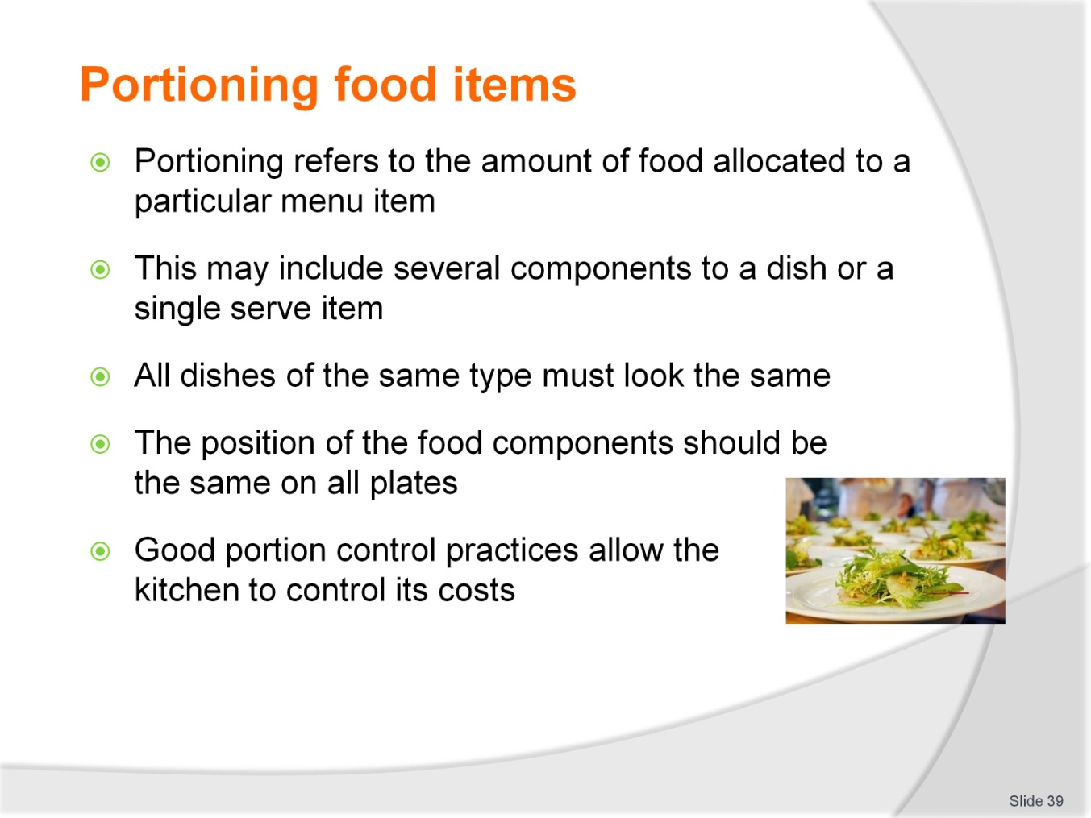
Slide No | Trainer Notes
Describe the impact of portion controlling on:
  - Customers
  - Costs to business.

Slide
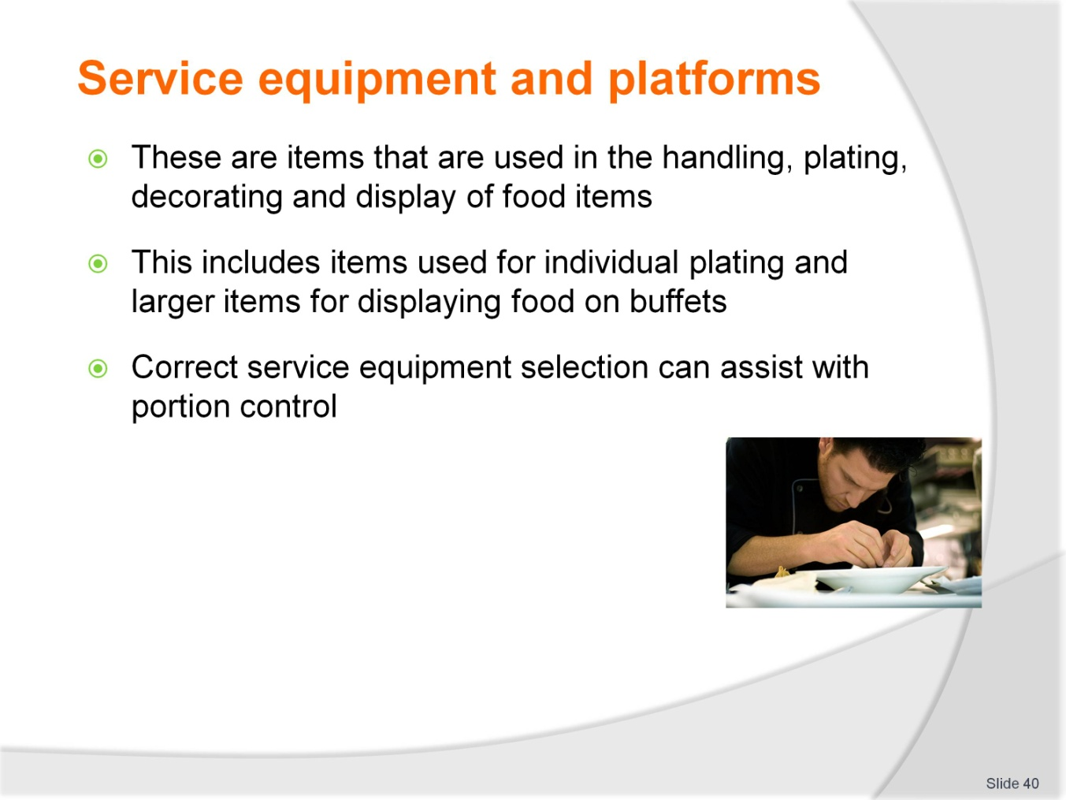
Slide No | Trainer Notes
 | Overview of service equipment and serving platforms/vessels.

Slide
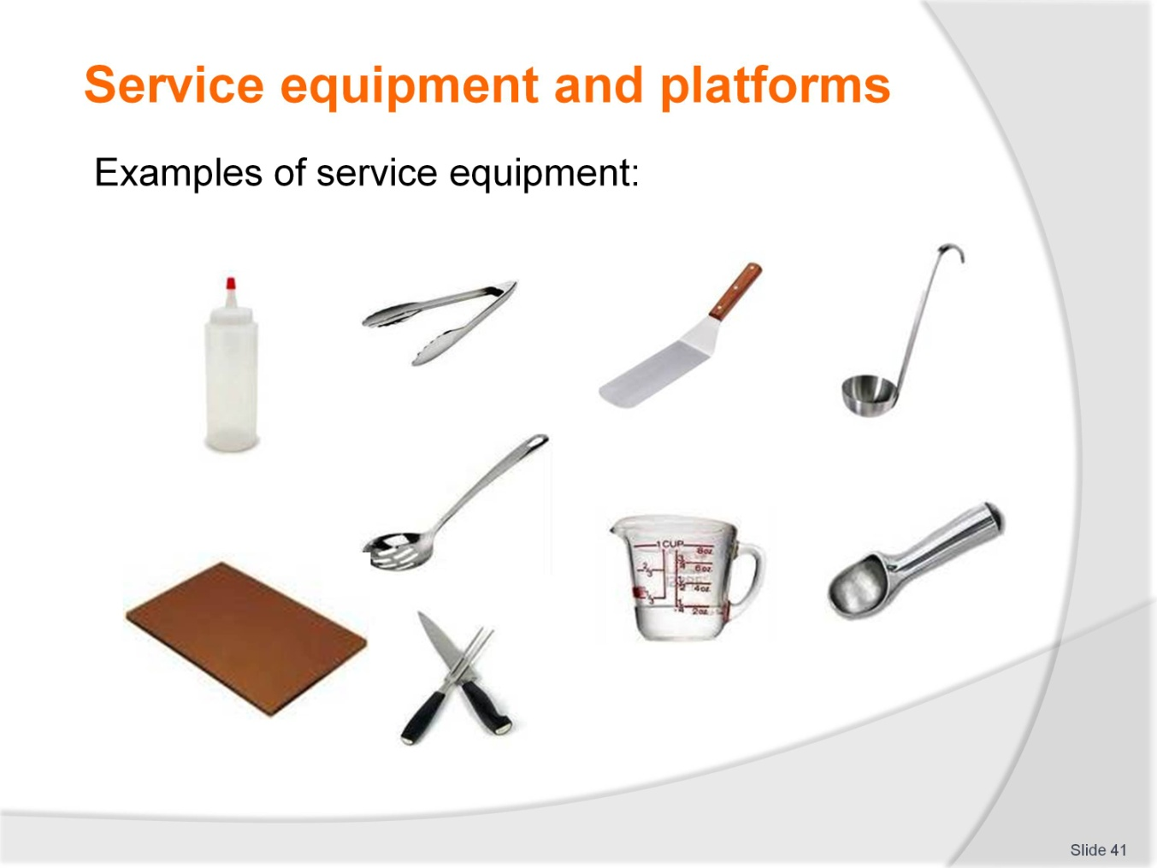
Slide No | Trainer Notes
Describe each piece of equipment and its uses in food service periods
What types of food would these items be used for when serving?
Seek feedback from students on equipment used in their workplace.

Slide
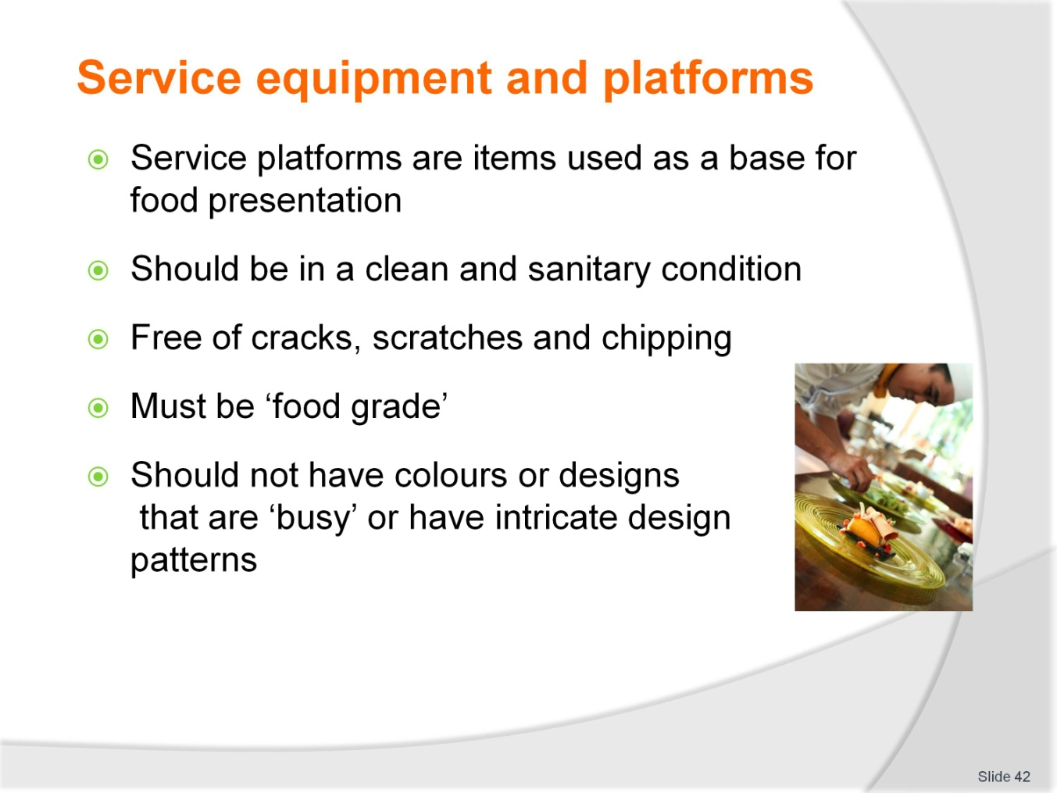
Slide No | Trainer Notes
Define the term ‘service platform’
Describe quality points to selecting service platforms using points in slide. Elaborate on these points.

Slide
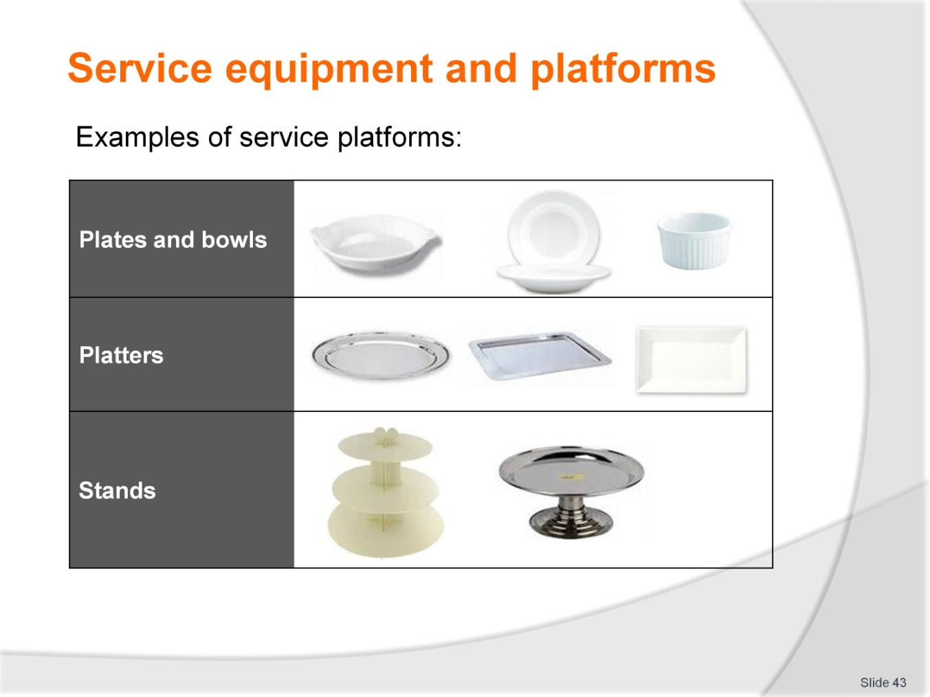
Slide No | Trainer Notes
Describe each item and its particular uses
The type/style of service that each of these items would be used for
Reiterate quality standards for selection of equipment.

Slide
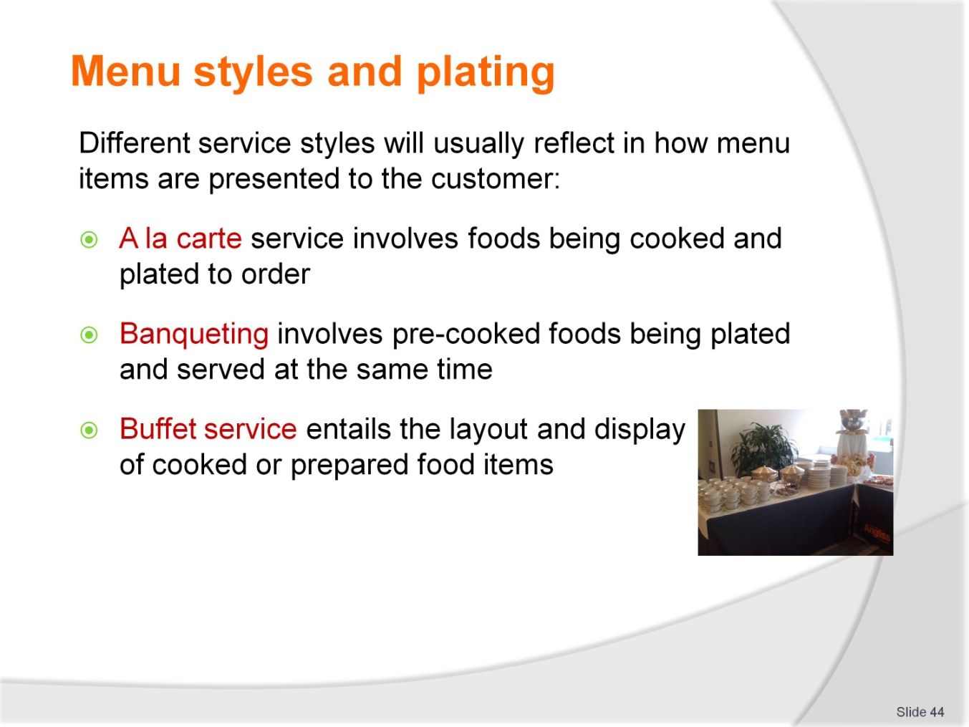
Slide No | Trainer Notes
Define each service style in the slide points
Elaborate on each style of service and provide reasons for different service styles (e.g. Banqueting opposed to A la carte for large groups dining at same time, the issues that would be faced with using an a la carte service style).

Slide
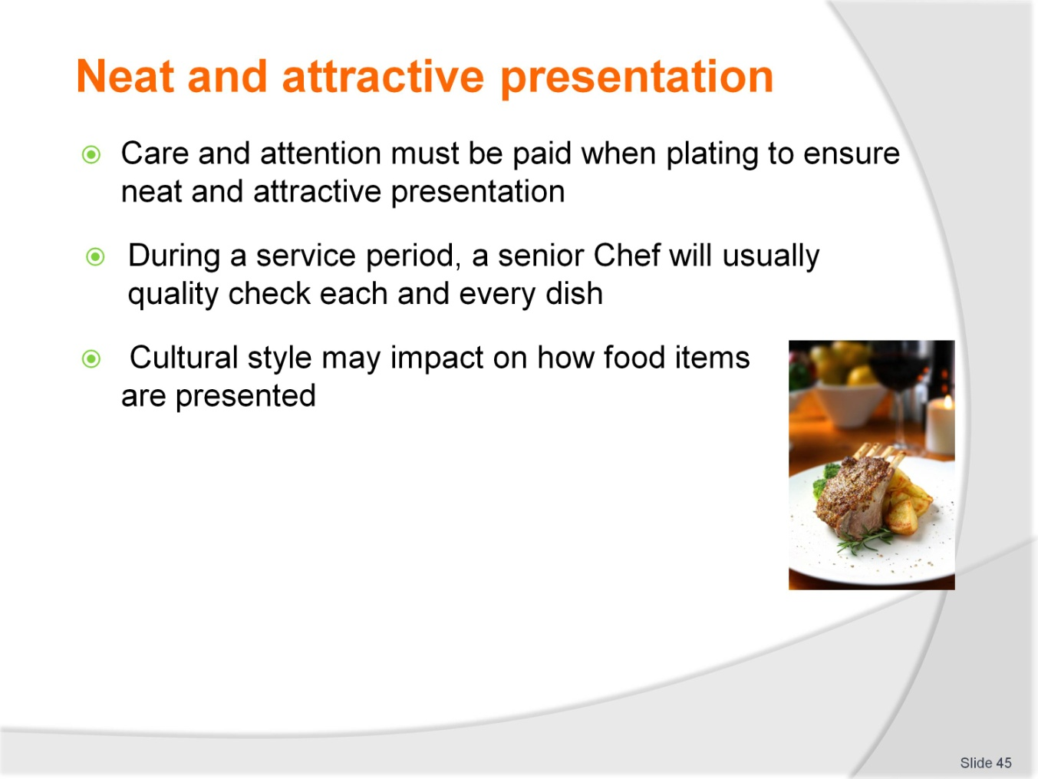
Slide No | Trainer Notes
Define the importance of ‘neatness’ and ‘attractiveness’, particularly from the customers perspective
Give examples of poor plating and presentation
Describe the impact of untidy or unattractive food presentation on diners and the business reputation.

Slide
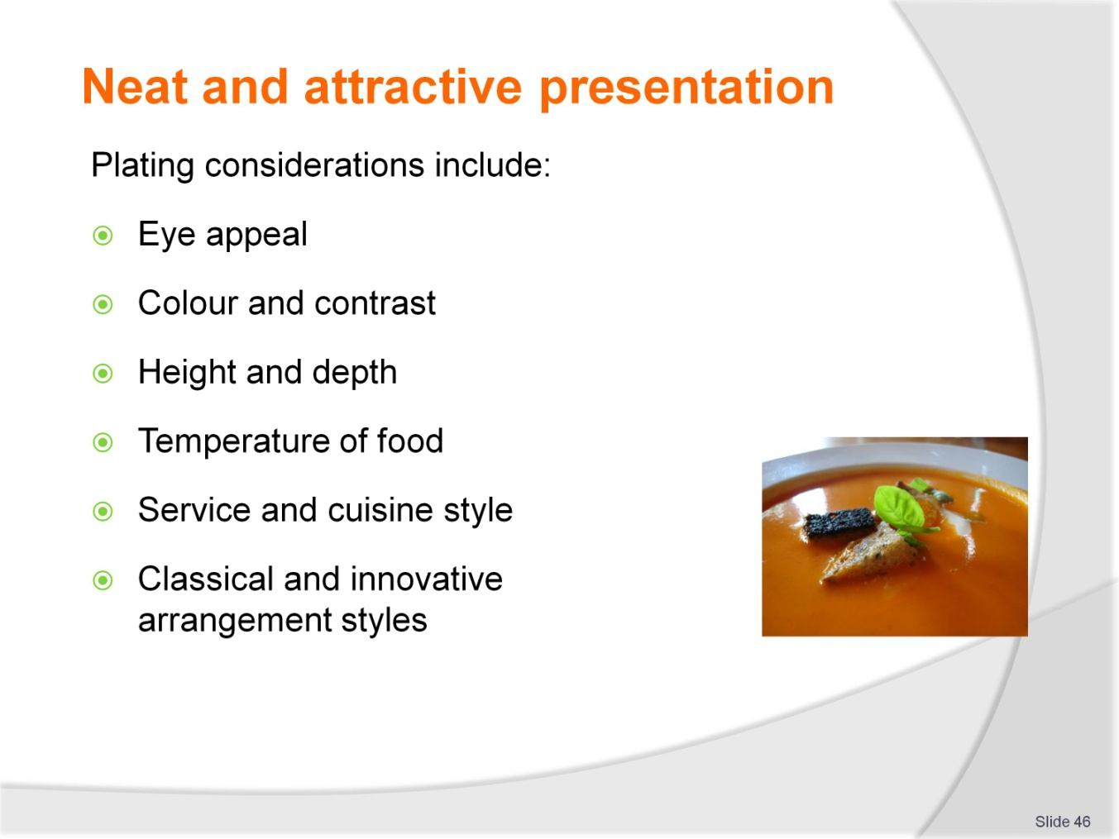
Slide No | Trainer Notes
Define each point in slide
Give examples of each point and define the importance of all elements being utilised for food presentation.

Slide
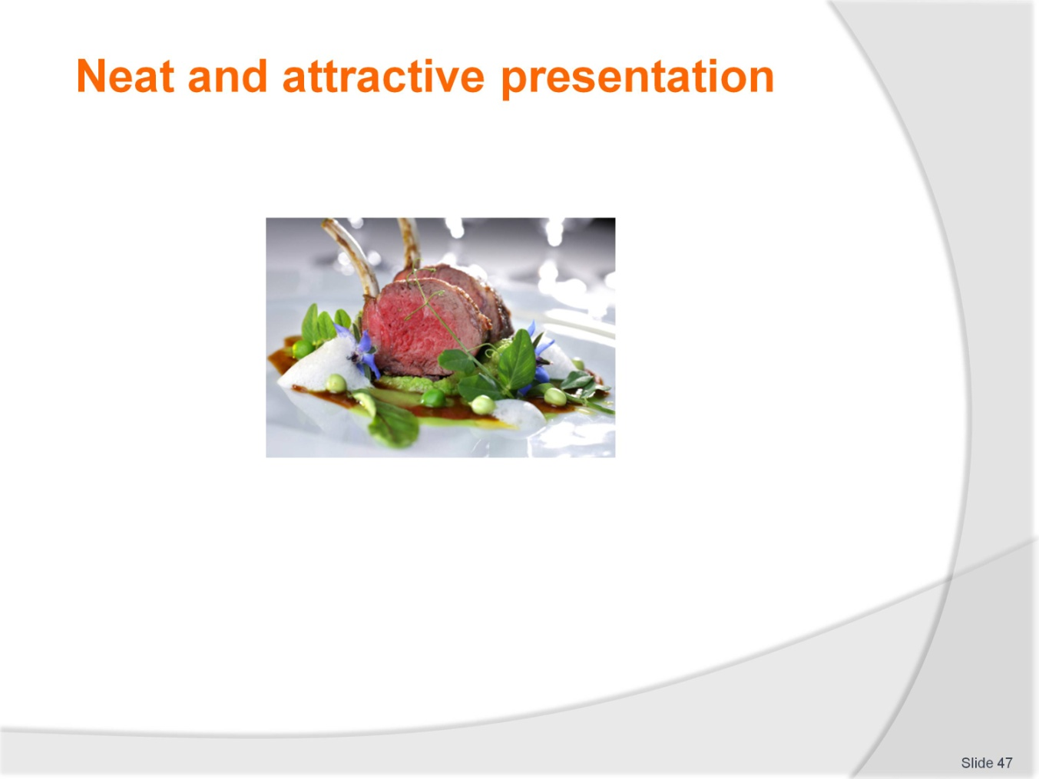
Slide No | Trainer Notes
 | Utilise the picture and seek feedback on all elements being met for presentation of this dish.

Slide
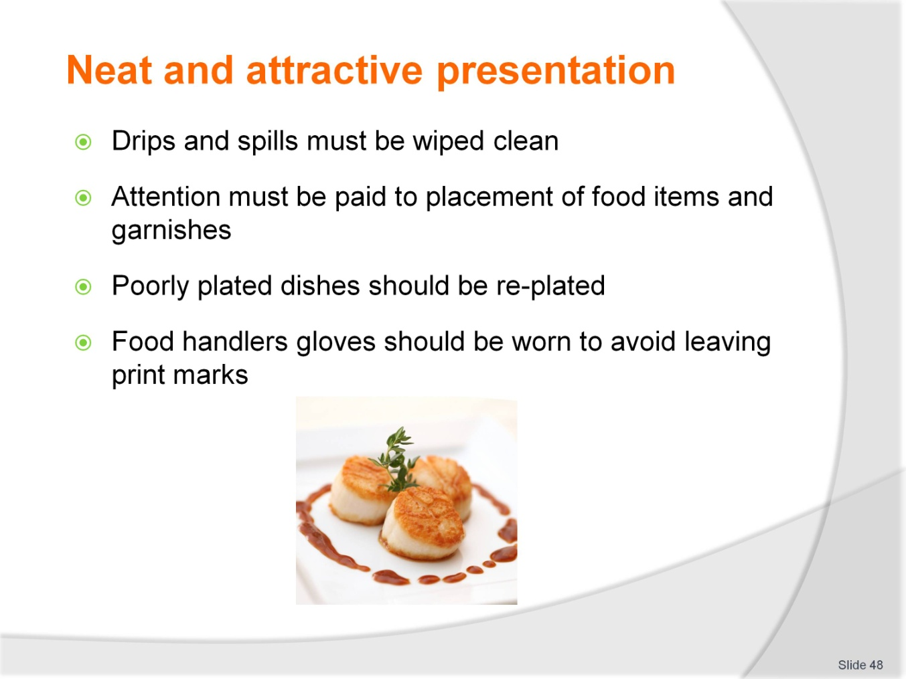
Slide No | Trainer Notes
Define the points in slide
Outline the critical aspects of plating food in relation to quality of presentation
Point out the impact of poorly plated or poorly presented food on the customer’s opinion of the business standard
Point out the customers expectation when paying for an expected high quality meal.

Slide
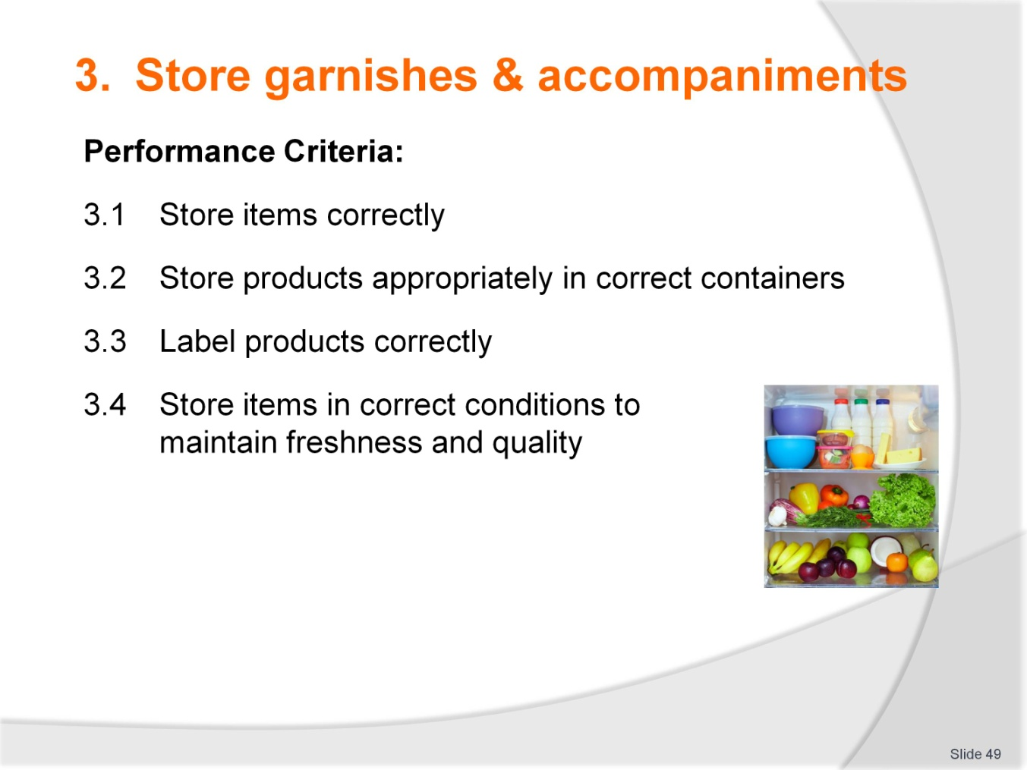
Slide No | Trainer Notes
 | Introduce the performance criteria to the trainees.

Slide
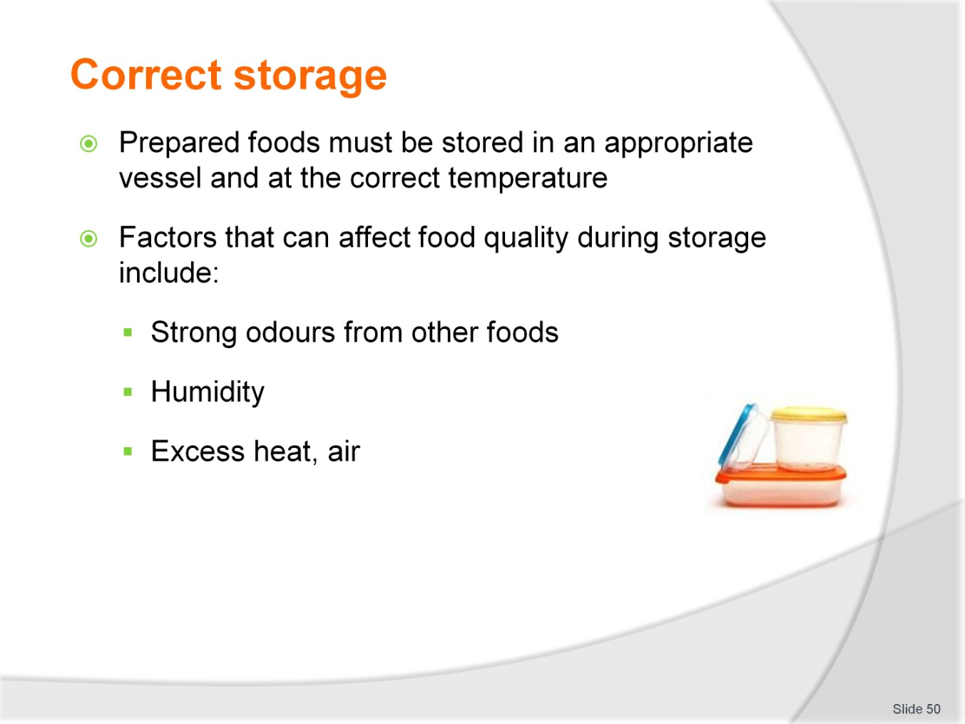
Slide No | Trainer Notes
 | Ask trainees to suggest what methods might be used to avoid some of these problems.

Slide
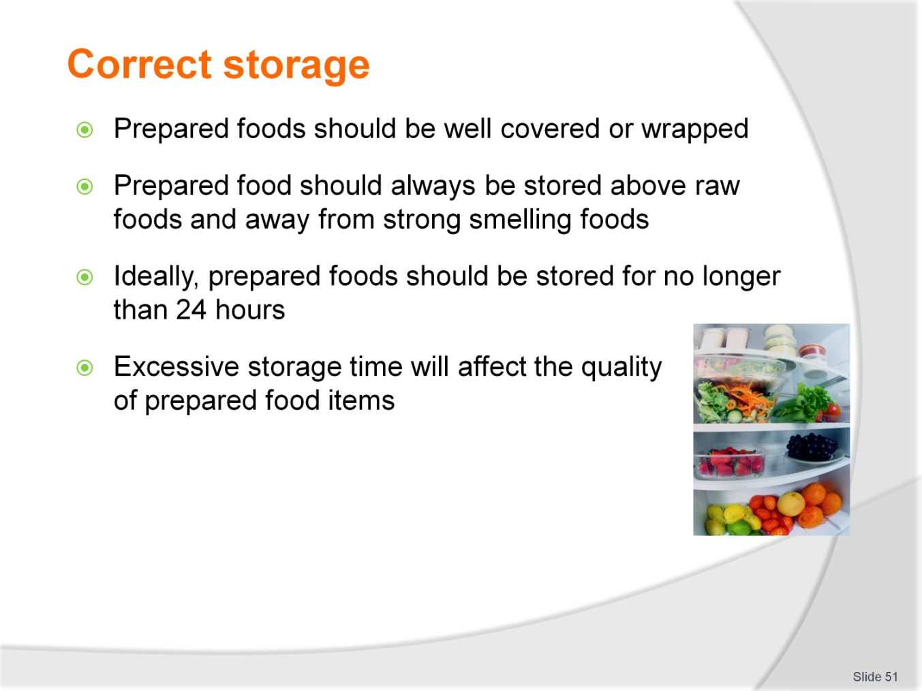
Slide No | Trainer Notes
Give an outline of why correct food storage practices are important in relation to quality and hygiene
Read through and elaborate on each point in slide.

Slide
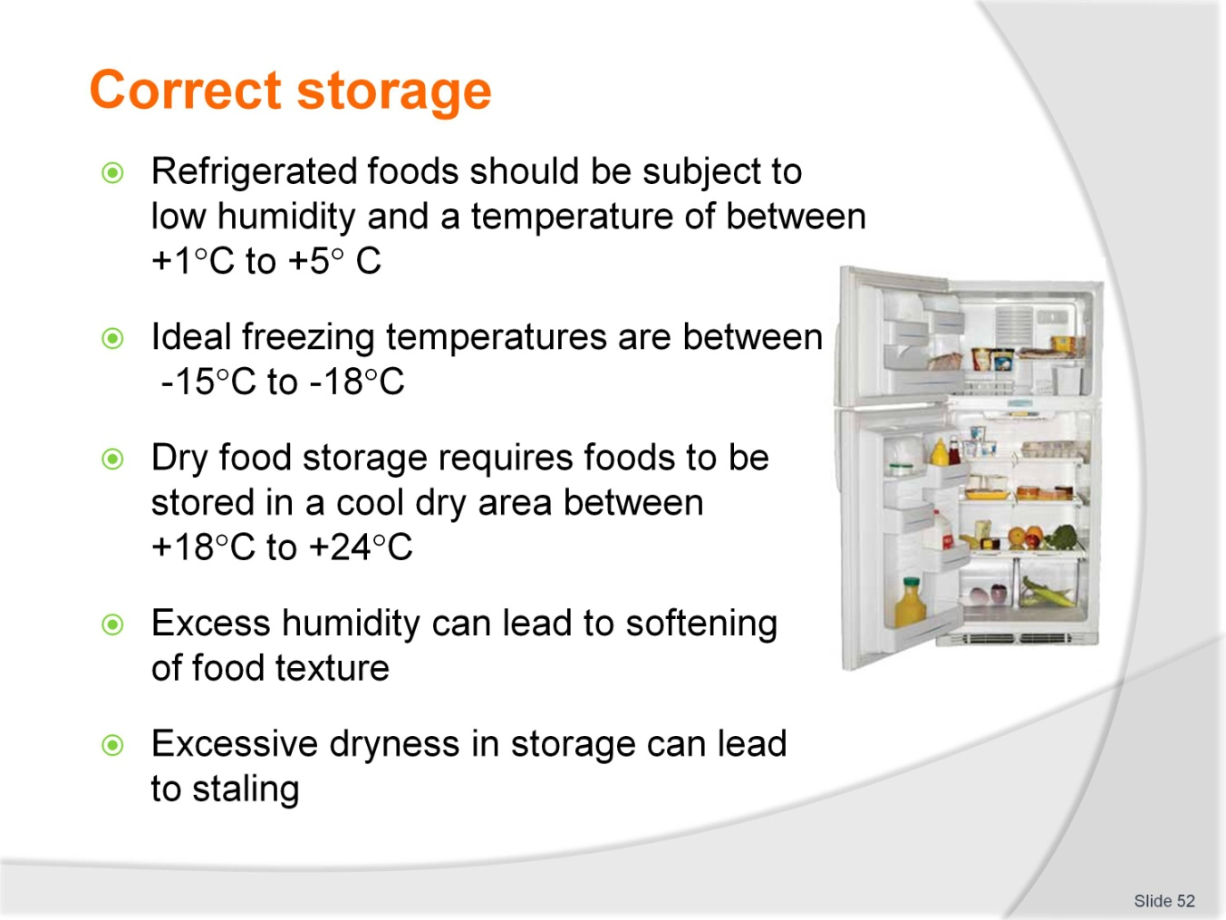
Slide No | Trainer Notes
Briefly describe the 3 main food storage areas
Define foods that may be stored in each area
Give reference to HACCP based food safety programs where storage conditions are outlined.

Slide
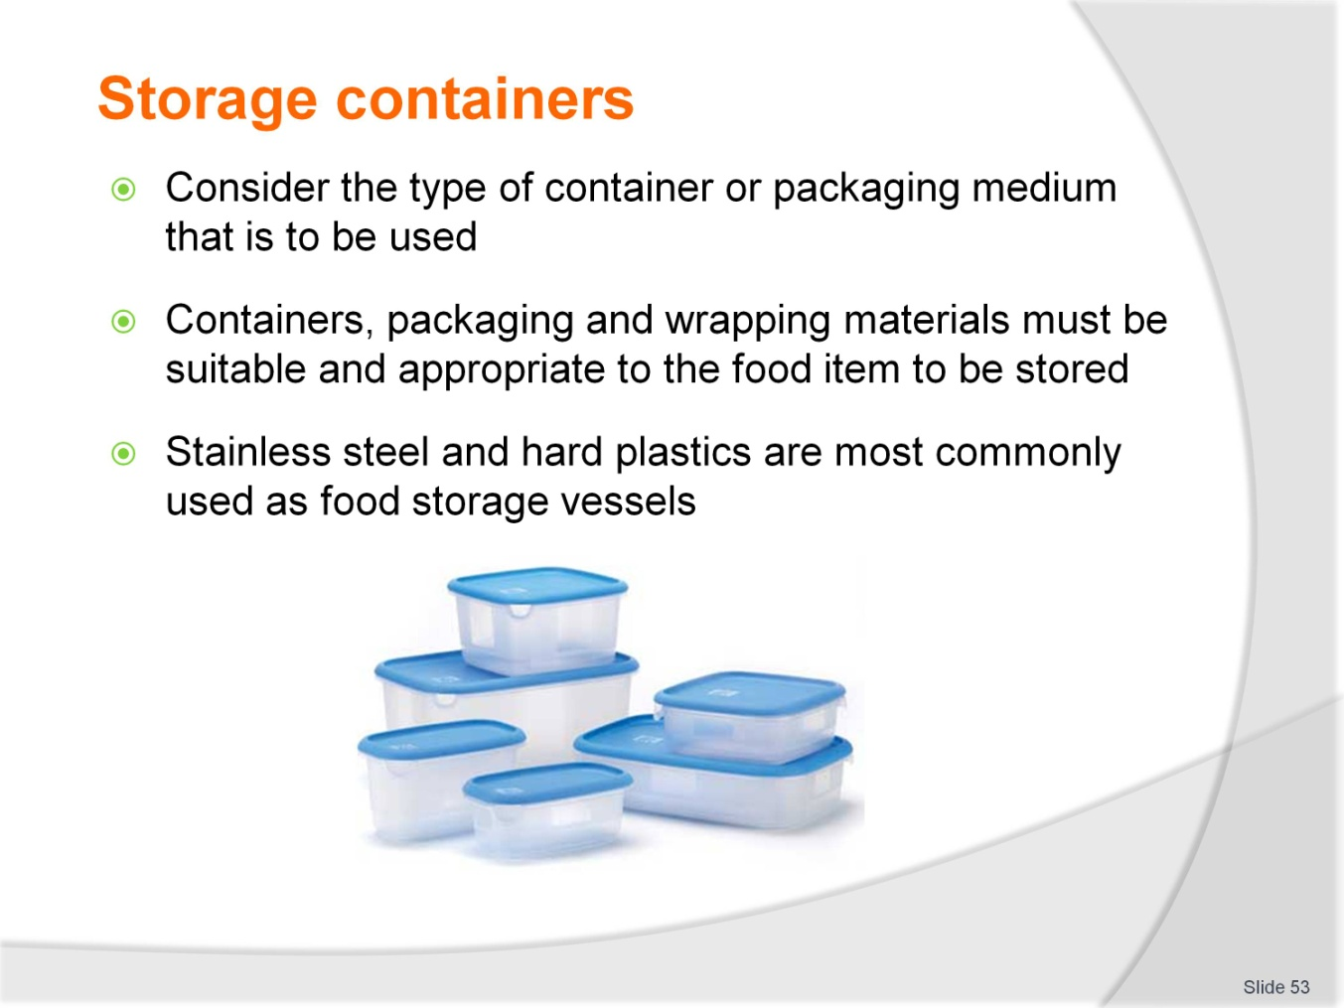
Slide No | Trainer Notes
Give an overview of storage containers used in food businesses
Read through and elaborate on each point in slide
Describe how correct selection impacts on food quality.

Slide
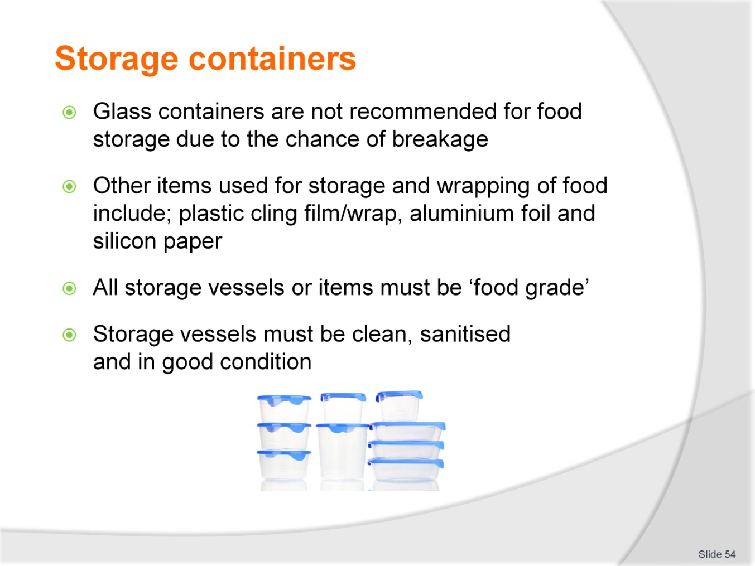
Slide No | Trainer Notes
Read through and elaborate on each point in slide
Outline the term ‘food grade’ and discuss items that may not be suitable for food storage.

Slide
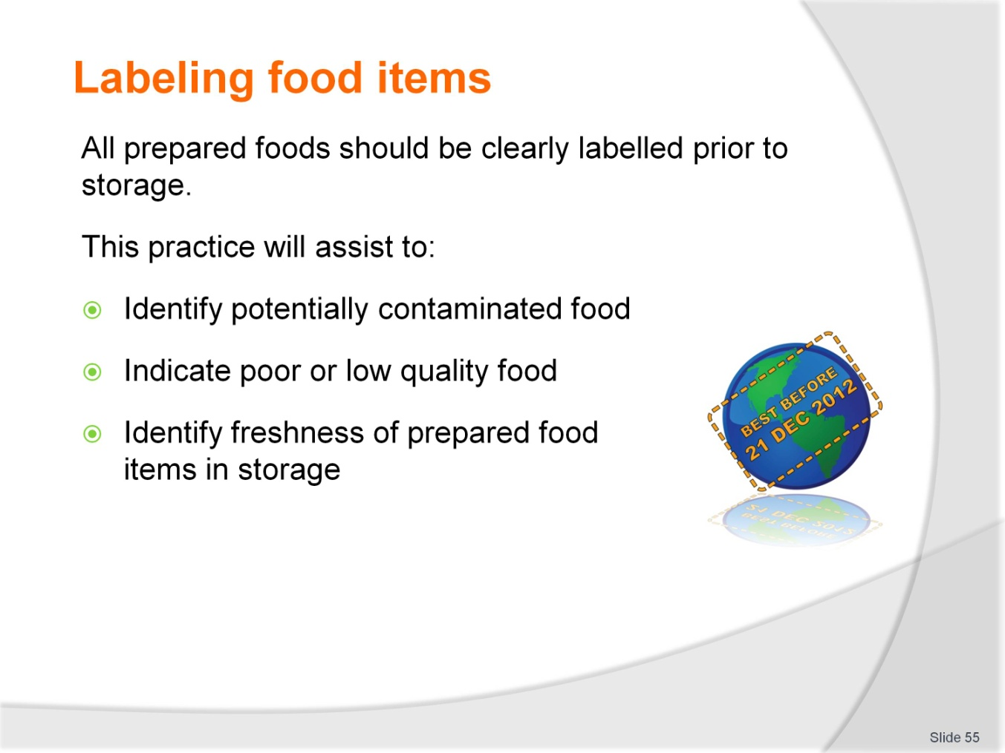
Slide No | Trainer Notes
Outline the requirements for labelling of foods in storage
Read through and elaborate on each point in slide
Give some examples/repercussions of having unlabelled food in storage.

Slide
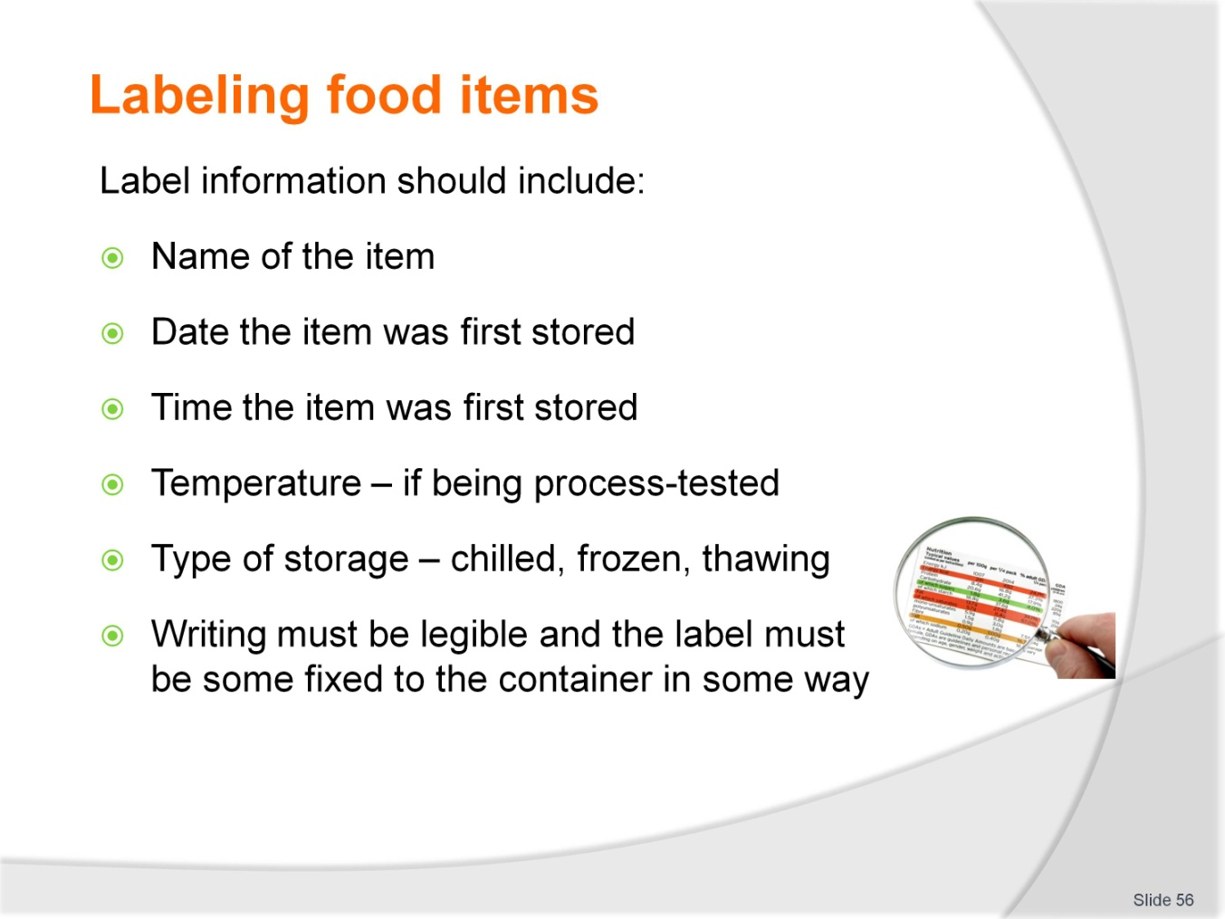
Slide No | Trainer Notes
Read through each point in slide
Give examples of types of labels available for food storage.

Recommended training equipment
- Chefs knives including:
- Large cooks knife
- Paring knife
- Turning knife
- Filleting knife
- Palette knife
- Cutting boards
- Peeler
- Zester
- Parisienne and noisette cutters
- Small shape cutters
- Pastry cutters
- Sieves and dredgers
- Squeeze bottles
- Piping bags and nozzles
- Chafing dishes and canned fuel
- Gastronorm type containers and lids
- Bain Marie
- Plate warmers
- Coolrooms and refrigerators
- Freezers
- Hot boxes
- Platters and salvers
- Stainless steel bowls of varying size
- Portion cutting guides
- Ladles
- Measuring spoons, cups and jugs
- Egg slide
- Spatula
- A variety of plates of differing shape and size
- Silicon paper
- Plastic cling wrap
- Aluminium foil
- Plastic disposable containers with lids
- Day dots and food labels
- Butchers string
- Probe thermometer
- Access to ice cubes or crushed ice.

Instructions for Trainers for using
PowerPoint – Presenter View
Connect your laptop or computer to your projector equipment as per manufacturers’ instructions.
In PowerPoint, on the Slide Show menu, click Set Up Show.
Under Multiple monitors, select the Show Presenter View check box.
In the Display slide show on list, click the monitor you want the slide show presentation to appear on.
Source: http://office.microsoft.com
Note:
In Presenter View:
You see your notes and have full control of the presentation
Your trainees only see the slide projected on to the screen
More Information
You can obtain more information on how to use PowerPoint from the Microsoft Online Help Centre, available at: http://office.microsoft.com/training/training.aspx?AssetID=RC011298761033
Note Regarding Currency of URLs
Please note that where references have been made to URLs in these training resources trainers will need to verify that the resource or document referred to is still current on the internet. Trainers should endeavour, where possible, to source similar alternative examples of material where it is found that either the website or the document in question is no longer available online.

Appendix – ASEAN acronyms
AADCP | ASEAN – Australia Development Cooperation Program.
ACCSTP | ASEAN Common Competency Standards for Tourism Professionals.
AEC | ASEAN Economic Community.
AMS | ASEAN Member States.
ASEAN | Association of Southeast Asian Nations.
ASEC | ASEAN Secretariat.
ATM | ASEAN Tourism Ministers.
ATPMC | ASEAN Tourism Professionals Monitoring Committee.
ATPRS | ASEAN Tourism Professional Registration System.
ATFTMD | ASEAN Task Force on Tourism Manpower Development.
CATC | Common ASEAN Tourism Curriculum.
MRA | Mutual Recognition Arrangement.
MTCO | Mekong Tourism Coordinating office.
NTO | National Tourism Organisation.
NTPB | National Tourism Professional Board.
RQFSRS | Regional Qualifications Framework and Skills Recognition System.
TPCB | Tourism Professional Certification Board.







